Movement of
YAH People!

Martin Luther King’s last speech!

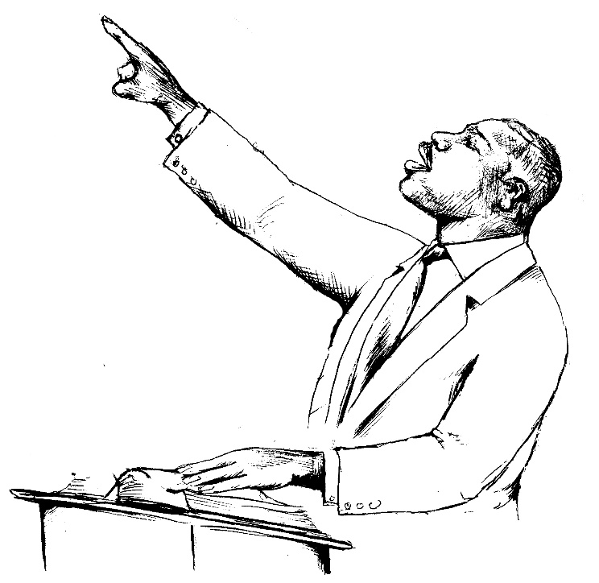

Well I don’t know what will happen now We’ve got some difficult days ahead. But it doesn’t matter with me now. Because I’ve been to the MOUNTAIN TOP. I won’t mind. “Like anybody, I would like to live a long life. Longevity has its place. But I’m not concerned about that now, I just want to do God’s will. “And He allowed me to go over to the MOUNTAIN. And I’ve looked over, and I’ve seen the PROMISE LAND. “I may not get there with you but I want you to know tonight that WE AS A PEOPLE WILL GET TO THE PROMISE LAND. “So I’m happy tonight. I’m not worried about anything. I do not fear any man. My eyes have seen the glory of THE COMING OF THE LORD.”
Martin Luther King Jr.
In looking at this, Martin Luther King’s last speech, one can’t help but note the obvious comparisons to Moses, who after working for the freedom of his beloved people was taken up into the mount and shown the Promised Land before his death
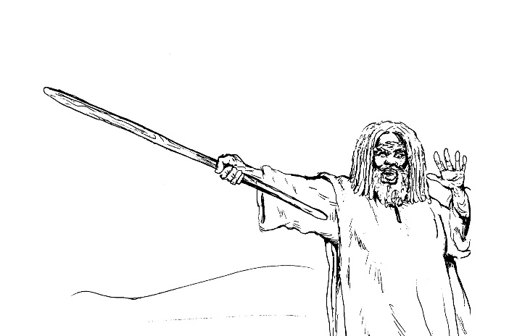

PROPHET LIKE MOSES
DEUT. 34:1, 5 And Moses went up from the plains of Moab unto the MOUNTAIN of Nebo, to the top of Pisgah that is over against Jericho. And YAH SHOWED HIM ALL THE LAND of Gilead, unto Dan.

And all Naphtali, and the plain of the valley of Jericho, the city of palm trees, unto Zoar.
And YAH said unto him, this is the LAND which I swore (PROMISED!) UNTO Abraham, unto Isaac, and unto Jacob, saying, I will give unto THY SEED (the children of Israel): I have caused thee to see it with thine eyes, but thou shalt not go over thither.
So Moses, the servant of YAH, DIED there in the land of Moab, according to the WORD of YAH.

SAVIOR WORD OF YAH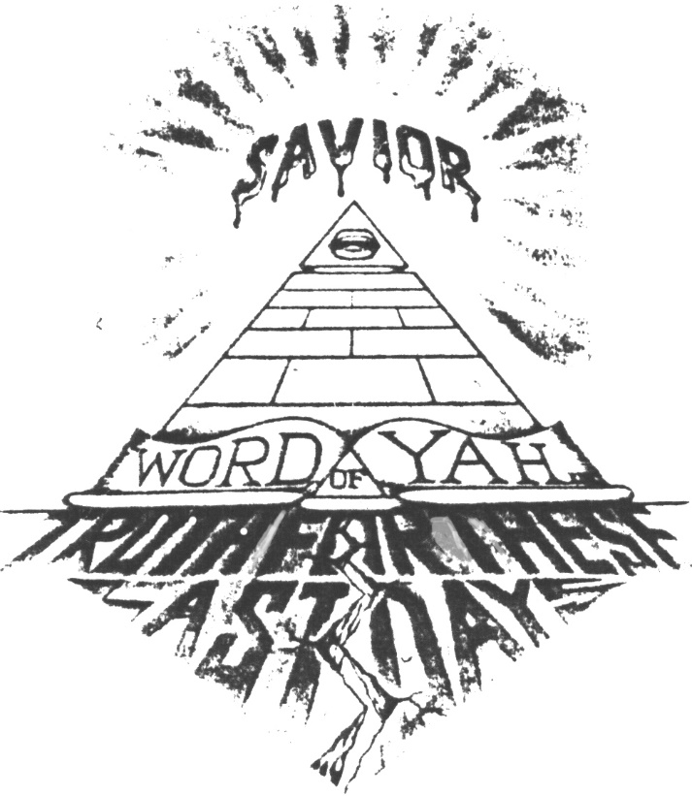

THE GREATEST MOVEMENT IN THE WORLD

When we think of Exodus and the “Movement of YAH people,” we think of Moses through the power of YAH plaguing Egypt and bringing His people out on dry land through the miracle of the parting of the Red Sea. But as great as history records that movement was, the Bible reveals there will be an even GREATER MOVEMENT to DELIVER! The descendants (SEED), of those ancient Israelites in these last days from our present Egyptian BONDAGE in North America and from the four corners of the earth, where He has scattered us in His wrath.
It’s obvious it was to this future movement Dr. King was referring when he stated, “We as a people will get to the PROMISE LAND.” And “My eyes have seen THE GLORY of the coming of the Lord.”

Jer, 16:13,15 Therefore will I cast you out of this LAND (Israel) into a LAND (America) that ye KNOW NOT (in ancient times) , neither ye nor your father and there shall ye SERVE other gods (powers) day and night: where I will not show you favor (CURSED!)
Therefore, behold, the days come, saith YAH, that it shall no more be said (REMEMBERED!), YAH liveth, that brought up (DELIVERED!) the children of Israel out of the land of Egypt;
But, YAH liveth, that brought up (RESURRECTED!) the children of Israel from the LAND of the NORTH (North America), and from ALL the land wither He had driven them and I will bring them again into their land (PROMISE LAND) that I gave unto their fathers.
What a glorious day that will be when YAH brings us back together from every heathen Nation to which He had scattered us. O how my soul yearns for that GREAT DAY prophesied in scriptures of the REDEMPTION of His people. Can you see brothers and sisters, coming from Jamaica and from the islands, from England and the States, from Ethiopia to South Africa, from Iran to India? All of His people RETURNING to the GLORY of the GREAT EL of Israel.

Movement of YAH PEOPLE!

Isa. 43:5, 7 FEAR NOT: fear I am with thee Israel): I will bring THY SEED (children) from the EAST, and Gather thee from the WEST;
I will say to the NORTH, GIVE UP and to the SOUTH, Keep not back: bring MY SONS (Ex.4:22) from FAR and MY DAUGHTERS from the ENDS (America) of the earth;
Even everyone that is called by MY NAME (Isa.63:19): for I have created him for MY GLORY, I have FORMED him; yea, I have made him.
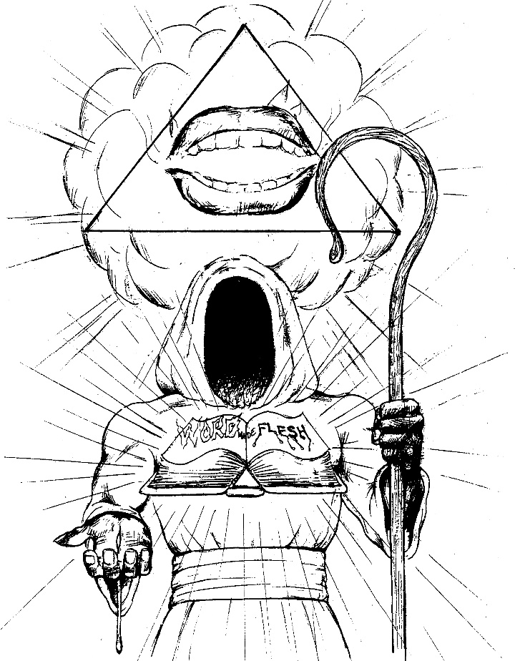
A SPIRITUAL MOVEMENT

Zech.4:6 Then He answered and spake unto me, saying, This is the WORD of YAH unto Zerubbabel (the name means captive in Babylon), Not by (physical) MIGHT, nor by (man made) POWER, but by MY SPIRIT, sayeth YAH of Hosts.
There are many similarities that exist between the movement of our people in ancient times and our present REDEMPTION from the graveyard of North America and the world. The principle similarity is that both movements were accomplished by the POWER of the Holy Spirit through a DELIVER or MEDIATOR between YAH and the people. The major differences being Moses was a mediator we could see in the FLESH, and Yahshua (the Son of Man) is on the right hand of YAH being lifted up in glory, but UNSEEN by us on earth.
This movement will be unique in that it will be a SPIRITUAL MOVEMENT in the NAME (authority) of the SAVIOR WORD OF YAH...NO MAN!

JOSEPH A TYPE OF UNSEEN DELIVERER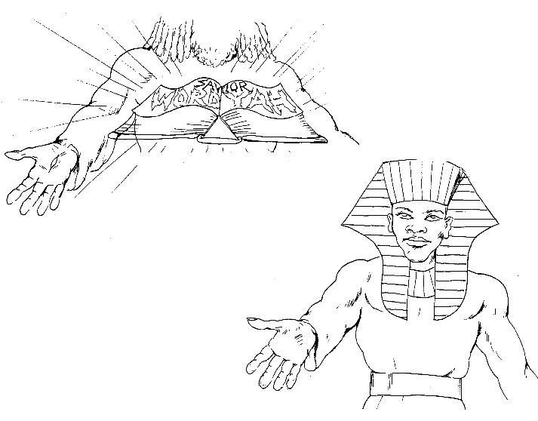

Looking carefully at the story of Joseph in the Old Testament we see a beautiful “TYPE” of this very truth of Messiah being our UNSEEN...DELIVER in these last days. Like Messiah, Joseph was thought to be dead by his brethren the children of Israel. But unknown to them he was not only ALIVE but was taken up out of the PIT (symbol of the grave) and out of the PRISON (symbol for Hell) to be made second only to Pharaoh (just as Messiah was made second only to YAH), and Joseph was a SAVIOR (a type of Messiah) from the FAMINE (a type of GREAT TRIBULATION) and DELIVERER to Goshen (a type of the PROMISED LAND).

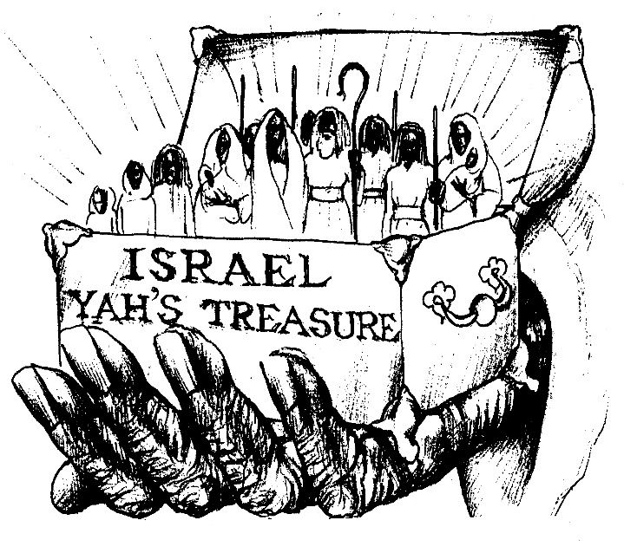
ONLY A REMNANT SAVED
The reality of an UNSEEN SAVIOR delivering His chosen people by His HOLY WORD through the POWER of the HOLY SPIRIT is undoubtedly one of the hardest concepts for a NATURAL MAN (mind) to comprehend.

I Cor. 2:14 But the NATURAL MAN (mind) receiveth NOT the things of the SPIRIT of YAH: for they are FOOLISHNESS unto him: neither can he know (UNDERSTAND!) them, because they are spiritual discerned (without His Holy Spirit [His mind] it is impossible to truly understand His will [WORD!])
This is why contrary to how we were delivered out of our ancient captivity, where ALL “the children of Israel went up HARNESSED (forced) out of the land of Egypt.”
Ex. 13:18. The scripture reveals that in these last days only a REMNANT of the vast multitudes of Hebrew scattered in this captivity will respond to His SAVING WORD through the SPIRIT.

Isa. 10.22 for though thy people Israel be as the SANDS of the sea (for Multitude), yet a REMNANT (small number) of them shall return

Jer.3:14 Turn (REPENT!), O backsliding children saith YAH; for I am married unto you: and I will take you ONE (family) of a city, and TWO (souls) of a family, and I will bring you to Zion:
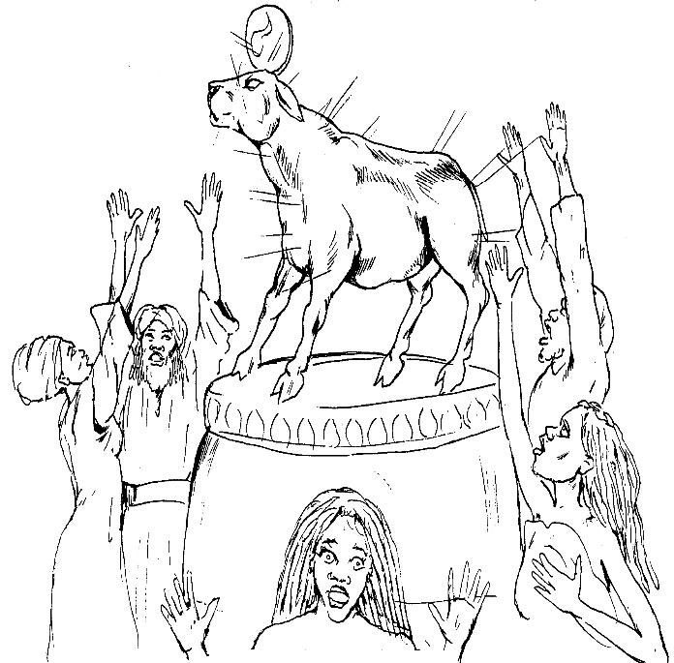GOLDEN CALF

When we examine the scriptures we can see Yah’s purpose all the time was to lead a SPIRITUAL (understanding) people through His indwelling WORD, as opposed to a purely PHYSICAL (ignorant) Nation being led by a man.

For example, when Moses was called up to the Mount to receive the LAW, the people rose up and forced Aaron to make them a GOLDEN CALF (false God). For they didn’t understand it was YAH an not Moses who brought them up out of the land of Egypt with a mighty hand, (Ex.32:11) and when the people saw that Moses delayed to come down out of the mount, the people gathered themselves together unto Aaron and said unto him, Up, make us gods, which go before us; for as this Moses, the MAN that brought us out of the land of Egypt, we know not what is become of him.
The Bible further witnesses that not only did the people make golden calves but also Rehoboam a King of Israel made the people golden calves.

1Kings12:28 Whereupon the King (Rehoboam) took counsel, and made TWO CALVES of GOLD, and said unto them, It is too much for you to go up to Jerusalem, behold thy (false) gods O Israel, which brought thee up out of the land of Egypt.
Please note carefully the following scripture that we might not make the same error.

I Cor. 10:11 Now all these things happened unto them (our ancient fathers) for EXAMPLES! And they are written for our ADMONITION (Warning!), upon whom the ENDS (last days) of the world are come.
Not understanding Yah’s HOLY WORD (OUR SAVIOR!) who manifested in the person of his SAVIOR… THE WORD made… FLESH!, who’s the Yah’s unseen right hand of POWER! men out of their ZEAL to SEE A PHYSICAL Messiah to DELIVER them, have made GOLDEN CALVES (false gods) out of their leaders. But the Bible WARNS!

Jer. 17:5 Thus saith YAH; CURSED be the man that TRUSTED in man, and maketh FLESH his ARM (strength), and whose heart departeth from YAH (his HOLY WORD).
Looking at my people (the DRY BONES) from down in America (the VALLEY), it is sad to have to report that nothing has changed. Many Hebrews look at the physical WORKS of their leaders and not at whether the person FULFILLS ALL of the scripture relative to YAH’s witness of the true Messiah to which ONLY Yahshua has fulfilled and is fulfilling through His POWER of the HOLY SPIRIT upon His FAITHFUL WITNESSES. In short the person is just a GOLDEN IMAGE (false god) they have created in their minds of who they imagine (NOT ACCORDING TO SCRIPTURE!) the Messiah would look like and do.
GOLDEN CALVES = FALSE CHRISTS
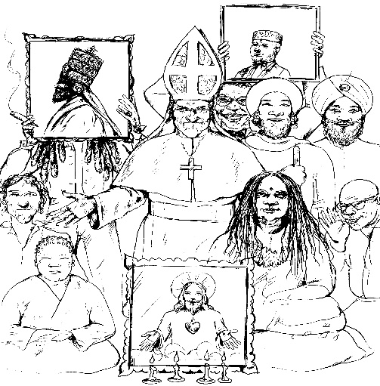

Math. 24:24-27 For there shall arise FALSE CHRISTS and FALSE PROPHETS, and show GREAT SIGNS and WONDERS insomuch that, if it were possible, they (IMPOSTERS!) shall DECEIVE the very ELECT (Yah’s chosen people).
Behold, I have told you before (verses 4, 5) it must be an IMPORTANT WARNING!)
WHEREFORE IF THEY SHALL SAY UNTO YOU, BEHOLD, He (the Messiah) is in the DESERT…GO NOT FORTH; behold, He (the Messiah) is in the desert… behold he is in the SECRET Chamber… BELIEVE IT NOT!
For AS (the same way) the LIGHTNING cometh out of the EAST, and SHINETH (across the sky) even unto the WEST, SO SHALL (in like manner) also the coming of the SON of MAN be.

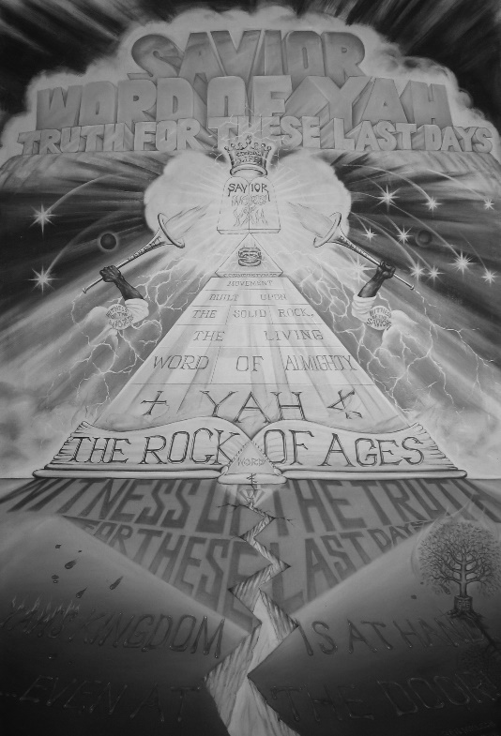

THE ENSIGN
Isa.11:11,12 And it shall come to pass in that day (these LAST DAYS!), that YAH shall set His hand again the SECOND TIME (first time was after our ancient Babylonian captivity) to recover the REMNANT of his people which shall be left, from Assyria, and from Egypt, and from Pathros, and from Cush, and from Elam, and from Shinar, and Homath, and from the Islands of the sea (in this present CAPTIVITY we’ve been scattered from Jamaica to England, from the United States to South Africa, from Ethiopia to Iran, from Belize to Brazil.).
And HE shall set up an ENSIGN for the NATIONS (that held us captive), and shall ASSEMBLE the OUTCAST of Israel, and GATHER TOGETHER the DISPERSED of Judah from the four corners of the earth.
Who or what is this ENSIGN that YAH will set up for the Nations for the GATHERING of Israel? It is none other than Yahshua (the Son of Man) as He is represented by His Saints (WITNESSES!) coming in his name (THE WORD!) and power (HOLY SPIRIT). We must understand that the scriptures reveal the Messiah doesn’t come personally in glory to America, for it specifically states He is to return to the Mount of Olives in Israel with GREAT POWER and GLORY to destroy the anti-CHRIST and save his ELECT. (Zech.14:1-+5, Rev. 16: 15,19 and Rev. 19:11, 21). How then are we DELIVERED from America (physical Babylon) to Israel?

Isa. 60:9 Surely the Isles shall wait for ME (the ENSIGN!), and the SHIPS of Tar-shish first to bring THY SONS from FAR (America and the Nations to which we were scattered), their silver and their gold with them, unto the NAME of YAH thy Elohim, AND to the Holy One of Israel (YAHSHUA, The SON of MAN), because He hath glorified THEE (the House of Israel).

The Mighty DOLLAR (the world’s God). On the GREAT SEAL of the United States found on the dollar bill the MASONIC founding fathers of the United States left the world in SIGNS and SYMBOLS the fact that they (European Gentile Nations) recognized us as being the Hebrews and our captivity a DIVINE sign from YAH.
If you can get a dollar please follow along as we explain. The words at the bottom of the seal (THE GREAT SEAL)(OF THE UNITED STATES) shows that these TWO SEALS should be read as ONE. The EAGLE symbolizes the UNITED STATES (daughter of Babylon, Psalms 83 & 137, Isa.47, Rev.13:11, 18) a unity of many Gentiles Nations. In the Eagles mouth the BANNER reads in LATIN (language of the Roman MOTHER language)

E Pluribus Unum (out of many [NATIONS]...ONE). Over the Eagle’s head appears THIRTEEN STARS which when drawn together forms ONE STAR (Star of David) symbolic of the ancient Nation of Israel.

The HAZE around the star indicates the Eagle (United States) is thinking of Israel (it’s Hebrew slaves) while looking at the GREAT PYRAMID with the ALL SEEING EYE (symbol of the Messiah) as the CORNERSTONE; “The STONE (Yahshua, THE WORD of YAH) the BUILDERS (House of Israel) refused has become the HEAD STONE of the CORNER.” (Psalms 118:22)

Over the EYE is the Latin inscription ANNUIT COEPTUS (translated “HE blesses our undertaking”). “and their adversaries said, against YAH, the habitation of justice YAH the HOPE of their fathers.” This is PROOF as being the same HEBREW SLAVES who built ancient Egypt into a WORLD POWER (as symbolized Pharaoh TREASURES CITIES, Pithom and Rameses, bondage, in mortar, and in brick, and in the field:”( Ex.1:11 and 14).

When this seal was designed we were prevented from learning to read or write. It is evident Yah’s purpose was to PUNISH us (America means TO PUNISH, from the Latin AMERICA) for rejecting HIS WORD (OUR SAVIOR). Great visionaries like the Honorable Marcus Messiah Garvey, who dreamed of the REDEMPTION of his people where ahead where ahead of their time for it was determined we would serve here 400 years (Gen.15:14). According to the PLAGUES (Economic collapse, famines, Aids, drugs, gang warfare, the homeless, insanity, murders, etc.) we see by the SIGNS of the TIMES Yah is beginning to REDEEM His people. Even all them that can HEAR...HIS WORD!

THE LAST STRAW
(that broke Negro’s back)

Lou Palmer a Chicago radio commenter used to end his provocative commentary with the unique phrase, “It’s enough to make a Negro turn BLACK.” Today our condition is much worst, “Enough to make a BLACK MAN turn HEBREW!”

Ex.5:10,11 And the TASKMASTERS (slave masters) of the people went out, and their OFFICERS (police) and they spake to the people (Hebrew slaves) saying, Thus saith Pharaoh, I will NOT GIVE you STRAW (education, training) where you can find it: yet not aught of your WORK (requirements) shall be diminished.

We have cried for freedom, justice, and equality in America and for our efforts they have increased the educational requirements for work to compete in an ever advancing technological world. While at the same time lowering our ability to gain access to that training and education.
Malcolm X very adequately accesses the plight of the Hebrew (so-called Black) slave in America as either falling into one of two classes. The so-called FIELD NEGRO and the so-called HOUSE NEGRO. The House Negro was set up as a model to the Field Negro of the success he could enjoy, if he could ever get into the house and eat of the crumbs that the master left, or wore, or even lay with expensive slave master use to lay. The problems is to get into the HOUSE (be accepted by master) required him to loose the only real thing he had...HIS MANHOOD!
This is the problem that confronts the so-called Negro, or Blacks (HEBREWS) in America. Minister Luis Farrakhan states it beautifully when he says “a white man’s HEAVEN (America).” He didn’t say a Negro’s hell, for America is “HEAVEN” to her docile domesticated European CLONES, who don’t have to worry about standing on their own feet like other Nations. They have been taught to wag their tails and look up to master to provide all their needs. But to a black (HEBREW) MAN, who only wishes the rights which other Nations enjoy (OUR OWN HOME LAND!); America is “Hell.” Just ask Harriet Tubman, Fredrick Douglas, Marcus Messiah Garvey, Elijah Muhammad, Malcolm X, Martin Luther King Jr., Bob Marley, Louis Farrakhan, and Ben Ammi (noted Hebrew leader who first fulfilled the prophecy ( Zechariah 12:7 ) in spearheading a successful movement to reunite Hebrews [so-called Blacks] from Babylon [America] to the PROMISED LAND [Israel], where they are presently under siege [WAR!] by Edom to starve them out of their own land). History records that every Hebrew who STOOD UP as a man in America, was either HATED, PERSECUTED, or KILLED as a reward.
The white man’s “HEAVEN” that the so-called “Negro leadership” has achieved here, had all but cost them their MANHOOD! They have learned to THINK (Satanic), TALK (forked tongue), LOOK (clean shaven), and FUNCTION (bowing down), in a way acceptable to the European master. He identifies with master so much he resents is African heritage. Heaven for him is vacation in Europe. He even becomes so sick he moves into the European community and can’t relate to the plight and sufferings of his own people. But with all his Masonic secrets, degrees, titles, money, etc., he doesn’t possess what any ignorant peasant of some third rate back based on his HOME LAND (not color). To the other Nations of the world, you DON’T EXIST!, but as PROPERTY (pack animal) to the United States.

GENOCIDE

Brothers and sisters you must understand we were Americas greatest resource. We constituted this countries mass cheap (free) labor force. A force which has made its captors the wealthiest Nation in the world. When the industrial revolution came about and that force was needed to work the factories in the north. A civil war was fought to free up the force to shift to the north. It had nothing to do with their humanity or love for us people.
Today is a highly technological, computerized, automated world where we computerize robot can replace hundreds of men, that cheap labor force is no longer needed. No longer needed you become target for extermination by the very Nation you helped build with your blood, sweat, and tears. When a nation carries out policies consistent with the systematic extermination of another Nation of people it is called GENOCIDE.

Ex.1:7,10-16-22 And the children of Israel were fruitful, and increased abundantly, and multiplied, and waxed exceedingly mighty; and the land was filled with them.
Now there arose up a NEW KING (new government policy) over Egypt (today America), today which knew not Joseph (remembered not how we were America’s blessing).
And he said unto his people, Behold, the people of the children of Israel are more and mightier than we:
Come on, let us DEAL WISELY (Genocide) with them; lest they multiply, and it come to pass, that, when it falleth out on war, they join also unto their enemies, and fight against us, and so get them up out the land.
And he said, When ye do the office of a midwife to the Hebrew women, and see them upon the stools; if it be a SON (man child), then ye shall kill him: but if it be a daughter she shall live.
And Pharaoh charged all his people, saying, Every SON (man child) that is born ye shall cast into the river, and every daughter shall save alive.
Today nothing has changed. The methods of genocide after some four hundred years may be more subtle. But the result is the same...DEATH! My people, it is time to WAKE UP! This isn’t a movie or a game their playing. It’s for your life. It’s no accident that the ratio in our Hebrew community is ten women to one man. It is no accident that Hebrew men lead the national statistics in death caused by murder, cancer, high blood pressure, alcoholism, drug, and gang related deaths. It is no accident our women are encouraged to take birth control pills and to abort (MURDER!) their own babies through constant radio advertisement for quick solutions to unwanted pregnancies. This is the highest form of GENOCIDE and MIND CONTROL. To have a people kill themselves. While on the other side, European Americans are taking fertility pills using test tubes fertilization to produce life from the otherwise DEAD WOMB.
Brothers and sisters be aware you are in battle for your life. You must know the nature of you enemy if you expect to overcome his attacks. Satan knows he can’t win against a STRONG UNITED FAMILY in... THE WORD, so his plan, even from the beginning, is simply to DIVIDE and CONQUER!

Gen.3:1 Now the SERPENT (Satan, Rev.12:9) was more SUBTLE (cunning) than any beast of the field which YAH Elohim had made. And he said unto the WOMEN (womb of man), Yea, had Elohim said, Ye shall not EAT (listen) to every TREE (doctrine) of the Garden? (You have to keep YAH’s Commandments? [Gen.2:16, 17])
Satan knows to get to the man he has to come through the women, when they are in a state of vulnerability; “When ye do the OFFICE (official policy) of a midwife to the HEBREW WOMEN, and see them upon the STOOLS (vulnerable); if it be SON (man child), then ye shall KILL him:” This shows us just what a coward Satan really is.
To show exactly how he destroys us as a people, let me reveal a POISONOUS CONCOCTION (Satan LIES, forbidden fruit) Satan employs to destroy us while all the time we are totally oblivious (ignorant) to his GENOCIDAL design toward us as a people. He thinks we are a bunch of ignoramuses, and in truth without the Father’s WORD, we are just that.
Let me begin by saying Satan knows very well the Creator’s WORD concerning the DIVINE ORDER of marriage and family;

I Cor.11:3 But I would have you know, that the HEAD of every MAN is the WORD; and the HEAD of the WOMEN is the MAN; and the HEAD of the WORD is YAH.

This is so very important for us to understand brothers and sisters. In this order the FATHER (YAH) is first, HIS WORD (Yahshua) is second, and the family (Man and Woman) is third, the man being the head of the Woman. If you have problem accepting this your Creator’s order only shows you have been POISONED by Satan’s LIES (forbidden fruit) already. Who do you think planted that SEED in your MIND that; “I’m liberated woman. I got a good job and a fine car. I don’t need no man...etc.” When you know you (the woman) are only half and are incomplete without the other half.
Man was formed to follow the WORD of his Creator to lead and provide for his family. The woman was formed to follow CARING, RESPONSIBLE, and PROVIDING leadership from her man. Satan knows to upset this delicate balance the family will SELF DESTRUCT. To achieve this aim Satan’s first ingredient is to tear down (castrate) the image of the man in the eyes of the women, and to debase the woman in the eyes of the man.
When the man is prevented from working to provide the needed substance to get the respect he needs, and at the same time the system rewards the woman with the authority of the children, employment, welfare, etc. which encourages her to follow her OWN MIND (be liberated), the result is evident. Rejected by the world (not a man), rejected by the SYSTEM (not a man), and finally rejected by his own WOMAN (not a man), he is sent on a path of SELF DESTRUCTION (drugs, alcoholism, gangs, crime, etc.). With the destruction of her man, she is forced into the whorish life style, where she falls victim to use and be used by WOLVES (including Gentiles who love to ravage our Hebrew sisters).

SATAN’S DEADLY POTION

With the destruction of a family the door is now open for Satan’s deadly poison to take effect. The single woman parent is now a fixture in a Hebrew community, which explains the meteoric rise of homosexuality. Add to this formula Edom’s control over our MASS MEDIA, enabling him to choose the sickest and most perverted of persons with the lowest or morels to be the SUPERSTARS and role models to our children, designed to turn them into little more than sex crazed animals. Add to this “CRACK” and other drugs which reduce us to animals who will perform any act with anyone for another hit. And finally add “AIDS” which has now crossed over to a heterosexual plague, and is no respecter of persons and the outcome is predictable. Thousands who have been seduced into a sexual promiscuous lifestyle will soon die a most hideous death. America will become the land of the ZOMBIES (the living dead)

Rev.18:2-4 And he cried mighty with STRONG VOICE, saying, Babylon the Great is fallen, DEVILS (Demons), and the hold of every FOUL SPIRIT, and a cage of every UNCLEAN and HATEFUL BIRD (Demonic spirits).
And I heard another VOICE from heaven, saying, COME OUT OF HER, MY PEOPLE, that ye be not partakers of her sins, THAT YE RECEIVE NOT HER PLAGUES.

LET PHARAOH GO!

Seeing these very real judgments and plagues coming upon America (daughter of Babylon) you basically have one of two options. You can stay and actively try to heal the ailment that confronts her or you can escape into your own land.

Jer.51:6 We would have HEALED Babylon, but she is NOT HEALED: FORSAKE HER, and let us go EVERYONE (Hebrews and Gentiles) into his own country: for her JUDGMENT reacheth unto Heaven, and is lifted up even to the skies.

Now you can keep praying for America. You can vote or for change or keep crying for justice, KEEP picketing, marching, or singing (fiddling while Rome burns), but her plague will only get worse until she reaps in full measure what she has own.

Rev.13:10 He that leadeth into CAPTIVITY (slavery) shall go into CAPTIVITY (sis America lead us into captivity?): He that killeth with the SWORD (did America kill with the Atomic Bomb?). Here is the patience and the faith of the saints.

Jer.51:6 FLEE OUT of the midst of BABYLON (America) and DELIVER every man his soul: be not CUT/OFF in her iniquity; for this is a time of YAH VENGEANCE; He will render unto her RECOMPENSE.

CHOOSE!

After being stripped from the FATHER LAND (Israel), and wondering through AFRICA (the Mother land) for 1600 years, we were gathered by the MIGHTY ARM (WORD!) of YAH and sent into America (PUNISHMENT!) to serve 400 years HARD LABOR (GEN.15:13). Packed like sardines in the stinking HELL of the BELLY of the SLAVE SHIP Jesus Christ (a type of Jonah in the fish’s belly), we were brought into chains to the land of the free,” where the strong who were survived were SOLD to the Gentiles for BONDMEN and BONDWOMEN (Duet.28:66,67), as the great and glorious day of OUR REDEMPTION drawest near, ask the average brother or sister what they think of returning to their OWN LAND (Israel, Northeast Africa) and he will no doubt answer, “Leave America? why you got to be CRAZY? This here is the greatest country in the world.”
It is so sad to have to report that the once most Holiest and Royal of Nations, though retaining some of their spirit and soul, has been so stripped to the bone (DRY BONES, Ez.37), that today they aren’t even a “skeleton” of their ancient selves. Our great and glorious HERITAGE (History, Land, Language, Culture, and Identity) has not been STOLEN (Oba.10:15) but completely WHITE WASHED (painted the Messiah and his people white) by the same forces who through their power over the MEDIA would label us as a “CULT,” though they know according to the WORD (the Holy Bible), we are the only people who fit all the prophesies of being the LOST SHEEP of the House of Israel.
It seems to always immediately come down to the same TWO CHOICES. Yah’s WORD (Holy Bible) or Satan’s LIES (TV). Either you will be DECIEVED into choosing purely Satanic LIES (II Thes.2:10,12) published through Edom’s control over television or you can choose to do as your ancient forefathers you read about in your Bible, who though often being elderly took hold of YAH’s WORD and not looking back, moved in FAITH to the PROMISED LAND.

HEB.11:8 By FAITH (in Yah’s WORD) Abraham (75), when he was called to GO OUT into a place (the PROMISED LAND) which he should after receive for an INHERITANCE, OBEYED; and he WENT OUT, not only knowing whither he went.

Heb.11:24,27 By FAITH Moses, when he was come to years, REFUSED to be called the son of Pharaoh’s daughter;
Choosing rather to SUFFER AFFLICTION with the people of YAH, than to enjoy the PLEASURES of SIN for a season;
Esteeming the REPROACH (correction) of the Messiah greater riches than TREASURES in Egypt (the world): for he had respect unto the recompense (JUDGEMENT!) of the KING (the government): for he endured, as seeing Him (YAH) who is INVISIBLE.

PURGED BY FIRE

“Purge me Oh Yah, melt me in the MIDST of you FIERY FURNACE until my soul is poured out unto thee O my Elohim, my HOPE, my SAVIOR! Forge me with Thine RIGHT ARM, even THY WORD, the ROCK of thy SAVATION. Hammer me, Hammer me, Hammer me home, until I’m shaped ANEW as a glittering SWORD in Thine IMAGE, perfectly FORMED to execute your will, O my Master.”

You can take the Hebrew out of BABYLON (America), but how do you take BABYLON (America) out of the Hebrews? For those who think this movement will be some kind of a picnic, I would hasten to inform them that FREEDOM comes with a price. THE WORD counsels us to first count the cost, Luke 14:28) to see whether we have enough to finish. When we look at America for example most people see wealth and comfort, but don’t stop to realize that the prosperity was paid for by the pioneering souls who constantly faced all kinds of dangers, often burying their loved ones along the way.
I’m afraid the conceptions most have had of an Exodus comes from Hollywood movie scripts rather than the WORD. But this is not make believe
, but a people coming “face to face” with the awesome power of the GREAT and TERRIBLE ELOHIM, who will purge out the REBELS and bring the remnant through the FIRE.

Ez.20:34,38 And I will bring you out from the people, and will gather you out of the COUNTRIES wherein ye were SCATTERED, with a mighty hand, and with a stretched out arm, and FURY poured out.
And I bring you into the WILDERNESS of the people, and there I will plead with you FACE to FACE.
Like as I pleaded your fathers in the WILDERNESS of the land of Egypt, so will I plead with you, saith Yah YAH
And I will cause you to pass under the ROD (Judgment), and I will bring you into the BOND of the (NEW) COVENANT:
And I will PURGE OUT from among you REBELS, and them that TRANSGRESS against Me: I will bring them forth out of the COUNTRY (America) where they sojourn, and they shall NOT ENTER into the land of Israel: and ye shall know that I am YAH.

Ez.22:21,22 Yea, I will gather you, and blow upon you in the FIRE of My WRATH, and ye shall be MELTED in the MIDST (of Jerusalem) thereof.
As silver is MELTED in the MIDST of the FURNACE, so shall ye be MELTED in the MIDST thereof; and ye shall know that I YAH have poured my FURY upon you.

LET MY PEOPLE GO!

Amos 3:7 Surely Yah YAH will do nothing, but HE REAVELETH (makes known) HIS SECRETS (His purpose) unto His SERVANTS the PROPHETS.

Ez.33:2,5-7 Son of Man, speak to the children of thy people (Israel) and say unto them, When I bring the SWORD (Destruction) upon a land (America), if the people of the land take a man of their coasts, and set them for their WATCHMAN:
If when he seeth the SWORD (Destruction) come upon the land, he BLOW THE TRUMPET (WORD!), and warn the people;
Then whatsoever HEARTH the sound of the TRUMPET (WORD!), and took NOT WARNING; his BLOOD (Death) shall be upon him. But he that taketh WARNING shall DELIVER HIS SOUL!
So though, SON OF MAN (the ENSIGN), I have set thee a WATCHMAN unto he House of Israel: therefore thou shalt HEAR the WORD at My (Yah’s) MOUTH, and WARN them from ME.

Math.11:15 He that hath EARS (Spirit) to HEAR (understand), let him HEAR (understand).

