KNOW THE TRUTH
(THE WORD OF YAH)
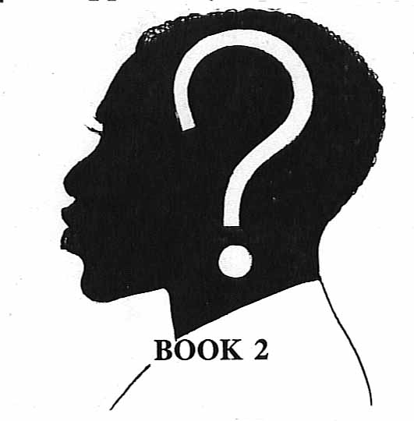
(THE WORLD’S BEST KEPT SECRET!)
THE TRUE IDENTITY
OF THE
SO-CALLED
AFRICAN-AMERICAN
REVEALED AT LAST

PART I
SEARCH FOR IDENTITY
(“the glass slipper”)
(THE WORLDS BEST KEPT SECRET!)
TRUE IDENTITY OF THE SO CALLED NEGRO

“WHO AM I?!
(THE WORLD’S BEST KEPT SECRET!)

(THE WORLDS BEST KEPT SECRET!)
TRUE IDENTITY OF THE SO CALLED NEGRO
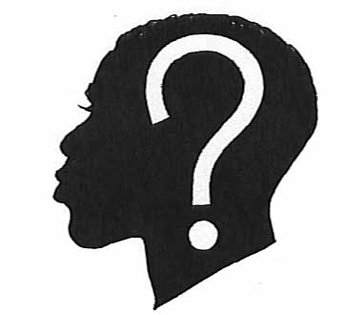
“WHO AM I?!
(THE WORLD’S BEST KEPT SECRET!)

BLACK SPEAKER…………………”I AM SOMEBODY”
Black audience…………………….”I am somebody”

BLACK SPEAKER…………………”I AM SOMEBODY”
Black audience…………………….”I am somebody”

BLACK SPEAKER…………………”I AM SOMEBODY”
Black audience…………………….”I am somebody”
And so goes the well-known CHANT made famous by Jesse Jackson, former National Director of Operation PUSH! Everyone knows that “We are somebody,” the question is “WHO ARE WE?” what NATION (Nationality) do we the “SO-CALLED Negro” (Black man and woman) of America and scattered to the four corners of the earth, belong to? Are we Egyptian? Or Ethiopian? We know we are African, but with so many Nations in Africa, how can we PROVE for sure (not just guess) which one of the many great African Nations we are descended from?

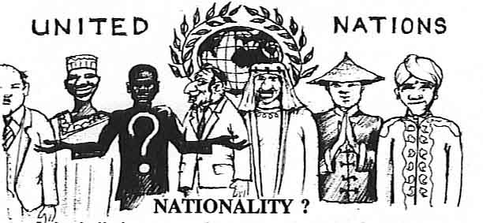
NATIONALITY?
It is vitally important that our readers clearly understand this book is not addressing RELIGION, but rather focuses exclusively on the subject of NATION (Nationality). In fact, we will go on to show that religion is one of the main causes of our destruction as a people.
NATIONALITY identifies all people on earth by their ancestry (blood), land, language, culture, and history, and is the greatest single knowledge all people fundamentally inherit at birth, with the glaring exception of the SO-CALLED AFRICAN-AMERICAN NEGRO, who has been completely stripped of the knowledge of SELF…his true NATIONAL IDENTITY!
The fact that the so-called Negro is a NATION, and shares the same common ancestry (blood), spirit, culture, history, etc. can be seen in fact that no other people on earth possesses the unique spirit the so-called Negro has been blessed with as a people, causing the world to aptly name us “SOUL PEOPLE.” Why even the common salutations with which we greet on another each day, bespeaks our common ancestry. For example, greetings like “Hey Blood,” “What’s up Folk?” “Shalom Brother,” “Greetings my Sister,” “what’s happenin’ Cous’?”, all speak to the fact that we recognize we belong to the same FAMILY! This is further illuminated when we understand that NATION is simply the individual’s extended family that shares a common ancestry (blood) land base, culture, language, and history.
We as a people must begin to understand the great importance of knowing one’s NATION, or NATIONALITY. Nation is the most powerful tie in the human experience, which upon examination can be proved to outweigh even one’s religion in importance. For example, when Nations go to war, one’s religion plays a secondary role: as Muslims will kill Muslim and Christian will kill Christian, etc., in defense of the Nation. We must begin to understand that NATION, and NOT RELIGION, is the common denominator in unifying any people. Understanding this, we can see how religion, instead of unifying us, has only served to alienate and divide us a people.
The so-called Negro’s lack of progress comparable to other nations who have spent much less time in America, can now be understood as being directly attributed to the SO-CALLED NEGRO’S …LACK OF KNOWLEDGE of his NATIONAL IDENTITY! By which the race could pull together, unite and advance.

Hosea 4:6 MY PEOPLE (Nation of Yisrael) are DESTROYED for LACK OF KNOWLEDGE…

This fact has not gone altogether unnoticed by our leaders. Down through history the question has been universally raised, “WHO ARE WE?,” “WHAT IS THE SO-CALLED NEGRO’S TRUE IDENTITY?” But to date no one has adequately answered this simple question. Today we see the vast majority of our people, from the common uneducated brother on the street, to the highly educated PhD’s, doctors, lawyers, theologians, etc. can’t intelligently identify their NATIONALITY.
The exclusive aim of this work is to amend this gross injustice. By the end of this book, you will know “THE WORLDS BEST KEPT SECTET,” the SO-CALLED NEGRO’S (Black man and woman’s) TRUE NATIONALITY, so that we like all other people can begin to unite as a NATION, and RISE UP!
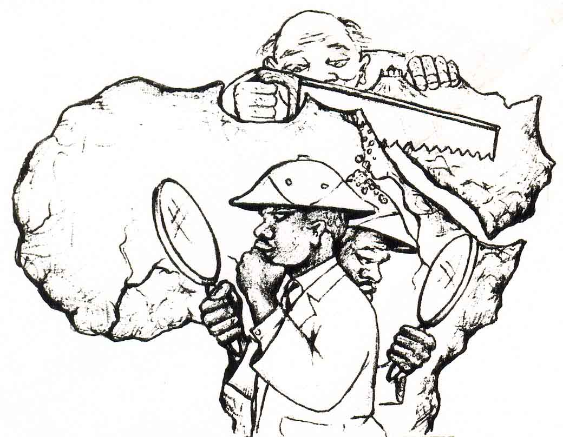

SEARCH FOR IDENTITY
Today we are witnessing an unprecedented interest in the study of African History and religion among Americans of African descent. The popular emergence of Egyptology, Islam, Rastafarianism, and Pan-Africanist movements coupled with the immense popularity today of clothes, jewelry, books, and art that reflects African culture, attests to the fact that their exists today an insatiable hunger among the descendants of those slaves stolen from Africa to find and identify with their true ‘African’ NATIONALITY!
The problem arises when one understands that AFRICA…IS NOT A NATION, but a CONTINENT, that consists of many NATIONS and TRIBES, each one possessing its own land, language, culture, custom, gods, religion, and physical characteristics, that IDENTIFY, and set each apart from the other. This was the design of the Most High: “…the Most High DIVIDED to the NATIONS their INHERITANCE (land) when He SEPERATED the sons of ADAM…”
Deuteronomy 32:8
The question arises then, how can we know for certain which one of the many African Nations, we (the so-called NEGRO) are from, that we can once again reclaim our true NATIONAL IDENTITY ( land , language, culture, history)?
At first glance this would seem to be an all but impossible undertaking: to somehow resurrect the so-called Negro’s true NATIONAL and TRIBAL ROOTS, after being so long and thoroughly CUT-OFF from our land and history, the institution of chattel slavery, where the slave was considered no more than property, all but destroyed the African family. Through the selective breeding, and selling off of family members, along with strictly forbidding the slave form speaking in his native tongue, all but insured that the slave wouldn’t transmit vital information about his National, Tribal, and oral tradition. The slave became a NONE PERSON, without land, language, culture, history, or IDENTITY. The once noble African, the father of civilization, was now reduced to little more than a pig eating, white loving replica of his European masters.
Though we were striped of our identity, history, land, language, culture, wealth, etc. there was one thing they couldn’t take from us. They couldn’t take away our SPIRIT, our SOUL, our deep rooted love and belief in the Creator. Now when you take the fact that we (the so-called Negro) are the most God obsessed, religious, spiritual, soulful, talented, gifted people on the face of earth, in addition to the fact that we already PROVED (by the Bible) beyond a shadow of a doubt that the ancient Yisraelites were BLACK with WOOLY HAIR(refer to Book 1), one can’t help but assume that the so-called Negroes must be the true descendants of that ancient, soulful, BLACK, HEBREW, (Yisraelite African) NATION. The fact that the ancient Yisraelites were a BLACK PEOPLE with WOOLY HAIR and obviously possessed great spiritual strength and soul, alone proves that we are in truth descended from that same great people.
Many Europeans are quick to argue the following point. Even though they obviously aren’t BLACK, or have WOOLY HAIR, and have never claimed to possess SPIRIT or SOUL, but they point out to their long rich Jewish tradition (in Europe), their numbers of converts worldwide, their present occupation of the land of Yisrael, their vast wealth, power, and influence in this present Euro-Gentile world system, etc. somehow proves their identity as he chosen people of God. But is tradition, numbers, wealth, power, etc., the evidence by which we should believe that those Europeans who claim to be JEWS are in fact are the ancestral descendants (SEED) of the ancient tribes of Yisrael?
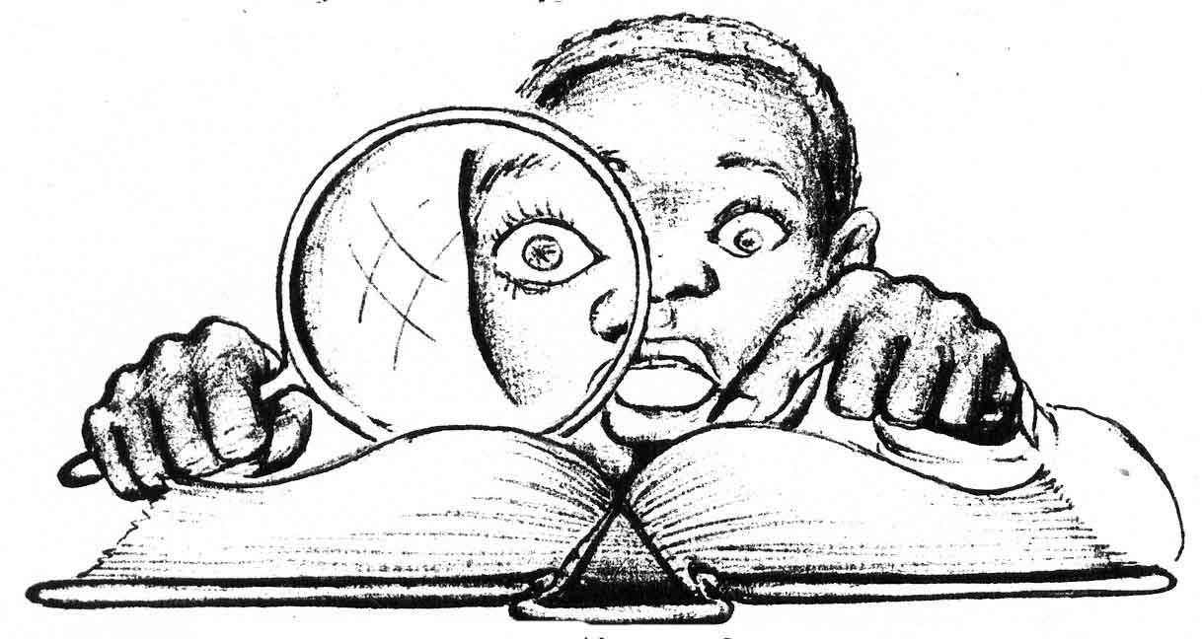
THE SURE SIGN OF PROPHECY
There does exist PROOF, by which we can know for sure who are the people of the Book. The PROOF amazingly enough was left in the BOOK (Bible) itself.
The SIGN He has left the world, not only will PROVE without question who His people are, but it will also prove to those skeptics that deny the existence of the Creator, that unlike all the false (man-made) gods, and vain religions of other Nations, YAH the El of Yisrael LIVES (the self-existing SPIRIT, the GREAT I AM), and is ALL POWERFUL and…ALL KNOWING!

Matthew 22:29 Ye DO ERR (make mistakes), NOT KNOWING the SCRIPTURE, nor the POWER of YAH.
Few people realize the PROOF of YAH’s existence is not based upon man’s faith, intuition, or some euphoric feeling one might experience, or on purported miracles He has performed, or on the overwhelming opinion of most people, He exists as evidenced by the millions of churches, temples, synagogue, in the world, etc. The Bible teaches proof of His existence is based upon His SURE WORD of PROPHECY (the ability to foretell the future) which CANNOT LIE! Being ever living and ALL KNOWING; He alone has the ability to KNOW and REVEAL (prophesy) the future thousands of years before it comes to pass.
Isaiah 46;9,10 Remember the former things of OLD (ancient Bible HISTORY): for I AM YAH, and there IS NONE ELSE (NO OTHER POWER!) I AM YAH, and there is NONE LIKE ME (with the power to prophesy the future). DECLARING (prophesying) the END from the BEGINNING, and form ANCIENT TIMES the things that are NOT YET DONE, saying my counsel (WORD!) shall STAND, and I will do all my pleasure:
Just as we know today for sure, YAHSHUA (whom the world calls Jesus Christ) is the MESSIAH based on Old Testament PHROPHECIES revealed hundreds, and some even thousands of years before his actual birth in the flesh. But which amazingly had already recorded His whole life and work 1.(Psalm 40:7) from revealing the place where He was to be born 2(Micah 2:5), His royal lineage from King David 3.(Isaiah 9:7), He would possess great wisdom, knowledge, and spiritual strength 4.(Isaiah 11:2), His preaching and ministry 5.(Isaiah 61:1), He wouldn’t speak His own words, but YAH would speak (HIS WORDS!) through Him 6.(Deuteronomy 18:18,19), He would be rejected 7.(Isaiah 53:3), betrayed and sold for thirty pieces of silver 8.(Zechariah 11:12, 13) crucified 9.(Zechariah 13:6 and 12:10), and DIE! 10.(Isaiah53:8 and Daniel 9:26), be resurrected 11.(Psalm 16:10), ascended into Heaven and given all power and dominion 12.(Daniel 7:13, 14), His return from Heaven in power and great glory to destroy the anti-Christ 13.(Isaiah 63:1-6 and Zechariah 14:4), and finally establish the Millennial STONE KINGDOM of YAH on earth 14.(Ezekiel 44:1, 3). All this was prophesied long before it came to pass in the Old Testament.
Read these amazing PROPHECIES for yourself, then compare them with the following New Testament accounts of the life of YAHSUAH and you see for yourself how beautifully they fit together, (John 5:39), (Matthew 2:1), (Matthew 1:1), (Luke 2:40), (Luke 4:18, 21), (John 5:46, and John 12:48, 50), (John 19:14, 15), (Matthew 27:3, 7), (John 19:34 and John 20:27), (Matthew 27:50), (Luke 24:26), (Revelation 5), (Revelation19:11, 21), (Revelation 20:4).
These events were prophesied in the Old Testament, and came to pass in the life, death, and resurrection of YAHSUA the Messiah (THE WORD made FLESH!) and FIT NO OTHER PERSON! that has lived in the past, that is living in the present, or that will in the future. The point is YAH would not leave something so important as to who HIS SAVIOR is to mere speculation, or to men’s imagination, so He confirmed Him by nothing less than the authority of HIS OWN NAME(HIS WORD!). Psalm 138:2
John 5:39, 43 SEARCH the SCRIPTURES (Old Testament); for in them ye (Yisraelites) think ye have ETERNAL LIFE: and they (Old Testament scriptures) are they which testify (BEAR WITNESS!) of ME (Yahshua’s name interpreted means SAVIOR OF YAH!)
I am come in my Father’s NAME (according to HIS WORD!), and ye receive me NOT: if another (AN IMPOSTER!) shall come in his own name (NOT ACCORDING TO THE WORD!), him will ye receive.
In the same way YAH didn’t leave the knowledge of who His CHOSEN PEOPLE are to mere speculation, but also made their unique fate a matter of PROPHETIC RECORD! He knew and recorded exactly what would befall His beloved people in the LATTER DAYS. All one simply has to do is examine the scriptural PROPHECIES that uniquely only fit one Nation of people on the face of the earth. This is the IFALLIBLE PROOF which…CAN NOT LIE, based solely on YAH’s inerrant WORD!
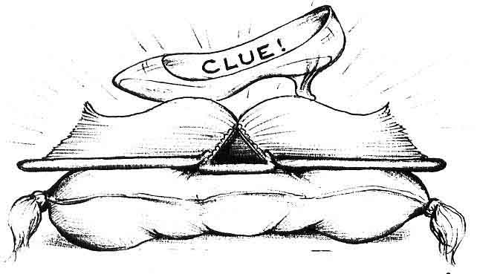

THE GLASS SLIPPER
We would like to use the well-known fairy tale of Cinderella, to illustrate the point of the prophecies of the Bible being the only sure SIGN YAH has left the word as PROOF of who His ancient people are.
Cinderella was a poor, orphaned, servant girl who was abused by her wicked step-mother and her evil daughters. But through the aid of her fair God-mother, her rags were miraculously transformed into royalty and she was allowed to attend the grand ball. The crown Prince of the land fell deeply in love with her, but at the stroke of midnight the spell wore off and her riches turned back into rags. The only evidence of her former glory was her glass slipper left behind in her rush to flee the ball. With the tiny glass slipper in hand, the prince went forth to find his true love. The declaration went forth, whoever fits the glass slipper would marry the Prince, and rule with him in his Kingdom. Try as they might, it fit none of the wealthy, well to do ladies of his tiny kingdom, but to every one’s surprise it fit the poor little servant girl’s foot, Cinderella, like a glove. She married the handsome Prince and lived happily ever after.
We find in the fairy tale of Cinderella many striking similarities with the true history of the Nation of Yisrael. Yisrael was described in the Bible as poor, naked and destitute when they were slave down in Egypt. Like the fairy God-mother, YAH miraculously delivered her out of poverty and slavery and transformed her into a glorious Kingdom until, in the days of King David and King Solomon, her fame, wealth, and power made her the glory of the ancient world. But her midnight came when, in 70 A.D., forty years after the death of the Messiah, she was conquered by the mighty Roman Empire. Those who escaped the sword and slavery, fled into Africa. Today the remnants of this once great Nation have all vanished with the sands of time like Cinderella. The only evidence left behind to prove who the descendants of that great ancient Nation are the PROPHECIES of the Bible, the “GLASS SLIPPER”. We challenge ALL NATIONS to look at the PROPHECIES which were designed only to fit one peculiar people on earth like a glove. Simply find the people who fit the prophecies of the Bible (the “glass slipper”), and you have found YAH’s CHOSEN PEOPLE. Here then are the amazing PROPHECIES (glass slipper), YAH has left to an unbelieving world of the PROOF of who today in TRUTH, are His beloved people Yisrael.

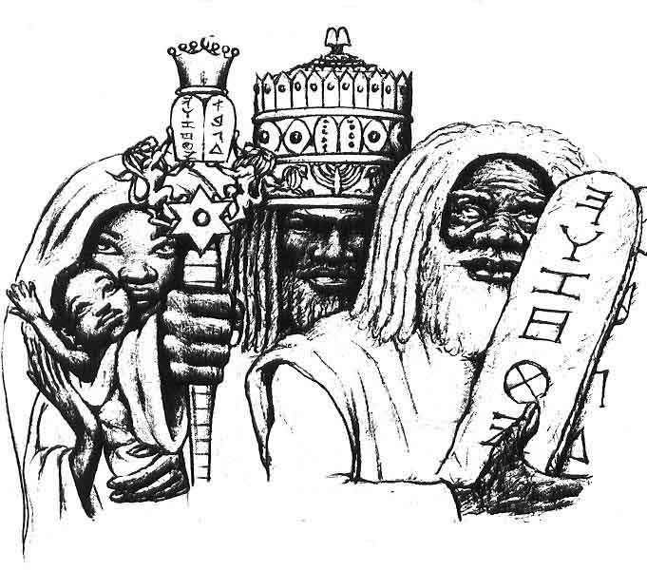
ANCIENT YISRAEL
BLACK with WOOLY HAIR!
The first clue (“SLIPPER!”) we have already seen in the overwhelming scriptural evidence that proves beyond a shadow of a doubt that the ancient Nation of Yisrael were a DARK SKINNED and WOOLY HAIRED people that lived in Yisrael, Northeast Africa (Genesis 2:7, Exodus 4:6, 7, Song of Solomon 1:5, Amos 9:7, Nahum 2:10, Revelation 1:14,15, Daniel 7:9, Numbers6:5). This material covered in detail in BOOK 1 of our series, “KNOW THE TRUTH (THE WORD of YAH!), The Ancient Yisraelites were BLACK with WOOLY HAIR!”
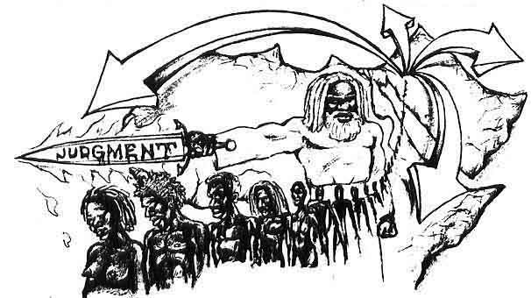

SCATTERED
The second prophecy (CLUE!) we would like to try on for size is the fact that the Bible reveals the true ancient Yisraelite Nation was to be conquered, driven from their land (Yisrael), and SCATTERED among all Nations of the earth!

Deuteronomy 4:26,27 I call Heaven and earth to WITNESS against your (children of Yisrael) this day, that ye shall soon utterly PERISH from off the LAND (Yisrael) where unto ye go over Jordan to possess it: ye shall not prolong your days upon it, but shall utterly be DESTROYED.
And YAH shall SCATTER you among the other NATIONS, and ye shall be left few in number among the HEATHEN, wither YAH shall lead you.
Deuteronomy 32:26 I said, I would SCATTER them into CORNERS (four corners of the earth). I would make REMEMBERENCE of them (Yisrael) to CEASE from among me.

These scriptures disprove the popularly held belief that the so-called Negroes are descended from the ancient Egyptians or Ethiopians, by the simple fact that both the Egyptians and the Ethiopians are still in their own land and their history doesn’t attest to them ever being driven out into another land. The so-called Negro on the other hand isn’t in his own land, in fact, he doesn’t even know where his land is other than the fact that he knows it’s somewhere in Africa. See how beautifully we, the SCATTERED (so-called Negro), having been driven from our own land, perfectly fit this PROPHECY (glass slipper).

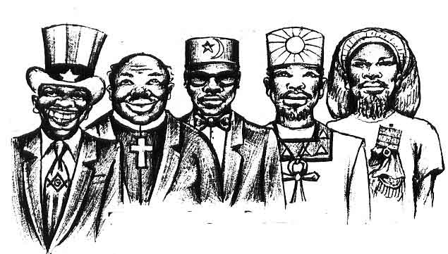
THE SO-CALLED NEGRO
“the Wanna Bes”

It never ceases to amaze me the great lengths to which my people (the so-called Negro) will go in their quest for an IDENTITY. Having LOST our true NATIONAL IDENTITY, our land, our language, our culture, our history, etc., yet still possessing our great spiritual strength and faith, you often find us believing more fervently in the false gods and religions of other Nations, more than those very Nations themselves.
For example, you’ll find you’re most zealous Christians to be your so-called Negroes. Their complete submission, awe and worship of the European is demonstrated in the IMAGES of their master’s European IDOL GOD (Je ZEUS), whom they proudly display in their churches, in their homes, and in their WHITE WASHED MINDS!

The proof of this is evidenced by the so-called Negroes’ preoccupation with straightening and curling their woolly hair, undergoing plastic surgery, or using heavy make-up to hid or reduce thick lips and noses, and the wearing of the most expensive European designer clothes, etc., all in a vain attempt to appear more acceptable to a western European culture, that will never truly accept its cheap African European imitations. Yet we go on altering our natural beauty in a vain attempt to conform to his European IMAGE (GOD) that they have IMPRINTED (PROGRAMMED!) into our WHITE (washed) MINDS. These European minded Negroes put you in mind of the movie “School Daze,” where a group of black Negro college girls were called “Wannabes” because they “WANNA BE” WHITE.
“Wanna bes” aren’t just confined to Negroes wanting to be European, however. Those African Americans who have rejected the European’s idol SUN GOD (Je ZEUS) fare little better turning for their identity to the false gods of Egypt, of Ethiopia, or other African Nation, etc. For example, in our “wanna be” roles we have become more knowledgeable about the Egyptian gods and pharaohs than the Egyptians themselves. We can also see in some of our people’s zeal to elevate the dead Emperor of Ethiopia, Hale Selassie, to a god, that we became more Ethiopian than the Ethiopians. All of this, mind you, at a time when these same African Nations themselves have long ago abandoned their own false idol gods for the TRUE and LIVING EL of the Bible, the HISTORY BOOK of the ancient African NATION of Yisrael, YAH’s CHOSEN NATION.
Today the DEAD (wood and stone) idols of other ancient African Nations, only holds meaning for two groups of people: archaeologists whose job it is to dig up the dead, or to the NATIONALLY DEAD, the so-called Negro, who in their groping in the darkness (IGNORANCE) for their identity, will almost believe in anything.
In this way, the so-called Negro’s condition can be likened to a cereal commercial that came out some years back which said, “Give it to Mikey, he’ll try it. He’ll try anything.” That’s us today we’ll try anything that comes along. This is the pitiful plight of the so-called Negro today, reduced to digging up the dead, idol gods of other Nations in our desperate attempt to find our true LOST IDENTITY. Reduced to a “WANNA BE” because we don’t know who we are.
The TRUTH is, the worship, study, and identifying with other African and European religions and Nations doesn’t make one become any more a part of that Nationality than a Chinese man can become a Roman, just because he practices the Catholic religion, eats spaghetti, and live in Rome, or a Russian man can become a Hebrew because he has converted to the Jewish religion, eats Matzo balls, and lives in Yisrael.

NATION(SEED!)…NOT RELIGION
UNDERSTAND! Your NATIONALITY is determined by what your father is, not by religion, date of birth(Zodiac), or what you ”wanna be.” Your NATION is determined by your FATHER(not mother) because the man carries the SEED! (Leviticus 15:16) This is why children take their father's NAME (...and NATION) If your father is Russian, you are a Russian. If your father is Japanese, you are Japanese. If your father is a HEBREW, your are a HEBREW…no matter what you “wanna be”
For example, an apple tree can only come from an apple seed. It doesn’t matter what you want to believe that seed to be, or what month (Zodiac sign) that seed was planted(born in). It doesn’t change what that apple seed is. You can plant it in different parts of the earth(mother), it doesn’t matter, and it still produces an apple tree. In the same way it doesn’t matter what Nationality your mother is (she represents the earth), your Nationality is determined by your father because you’re his SEED!

The points that no matter what the so-called Negro wants to be (English, Egyptian, Ethiopian, Arabic, etc.) we are a NATION from AFRICA, with a land, language, culture, history all our own that… CAN NOT CHANGE, even though we “WANNA BE” someone else.

Malachi 3:6 For I am YAH, I CHANGE NOT; therefore ye SONS (SEED!) of Jacob are NOT CONSUMED.

A NATION BLESSED…NOT RELIGION!
If we examine the Bible, we clearly see that YAH has chosen and blessed a NATION, the SEED of Abraham, Isaac and Jacob…and NOT RELIGION!

SEED OF ABRAHAM
Genesis 14:6-8 And I will make thee (Abraham) exceedingly fruitful, and I will make NATIONS (…NOT RELIGIONS!) of thee, and KINGS (David, Solomon, Yahshua the Messiah) shall come out of thee.
And I will establish My COVENANT between Me and thee and thy SEED (children) after thee in their generations for an EVERLASTING COVENANT, to be Elohim unto thee, and thy SEED after thee.
And I will give unto thee, and to the SEED (the children of Yisrael) after the, the land of thy sojournings, all the land of Canaan, for an EVERLASTING POSSESION; and I will be their Elohim.
SEED OF ISAAC
Genesis 23;3,4 Sojourn in this land (Canaan land, Yisrael), and I will be with thee, and I will BLESS thee; for unto the (Isaac), and unto thy SEED (NATION…NOT RELIGION), I will give all these countries, and I will perform the oath which I swear unto Abraham thy father;
And I will make the SEED (children of Yisrael) to multiply as the stars of heaven, and I will give unto thy SEED all these countries; and in thy SEED (true BLACK Yisrael) shall ALL the NATIONS of the earth be BLESSED;

SEED OF JACOB (YISRAEL)
Genesis28:13,14 And behold, YAH stood above it, and said, I am YAH the El of Abraham the thy father, and the El of Isaac: the land (of Canaan, Yisrael) whereon thou liest, to thee (Jacob, Yisrael) will I give it, and to thy SEED (NATION…NOT RELIGION);
And thy SEED (children of Yisrael) shall be as the dust of the earth, and thou shalt spread abroad to the west, and to the east, and to the north, and to the south; and in thee and in the SEED (true BLACK Yisrael) shall ALL the FAMILIES of the earth be BLESSED.
The question naturally arises, where is this SEED (NATION!) today?
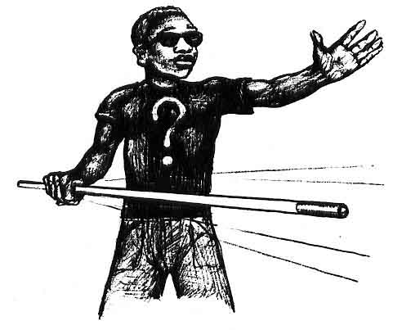
BLINDED!
The bible gives a clue to the mystery of where the true LOST SEED (children, NATION) of Yisrael is today, in an amazing PHROPHECY (glass slipper). The Apostle Paul revealed that TRUE YISRAEL was to be BLINDED until the LAST DAYS of the EURO-GENTILE POWERS ruling on earth (…or until TODAY!)

Romans 11:25: For I would not, brethren, (Paul speaking to Gentile Believers), that ye should be IGNORANT of this MYSTERY, lest ye should be wise in your OWN CONBCEITS: that BLINDNESS IN PART (temporary NATIONAL BLINDNESS) is happened to Yisrael, until the FULLNESS (time of the end!) of the GENTILES be come in (today the LAST DAYS!)

Do you know any other people on earth beside the so-called Negro who have been BLINDED not to know who they are or where they came from?

AMNESIA VICTIM
In 70 A.D., forty years after the Messiah was rejected and CUT/OFF (sacrificed), the Roman general Titus destroyed Jerusalem and the REMNANT that escaped starvation and the sword, fled down into Africa, where they eventually underwent a “Spiritual Blindness,” a kind of NATIONAL AMNESIA. Now an AMNESIA VICTIM suffers a temporary MEMORY LOSS, where he loses all sense of his TRUE IDENTITY (Name, Land, Language, Culture, etc.). In this helpless condition he is totally vulnerable, at the mercy of his bitterest enemies (Nations), who at that point could BAND TOGETHER (United NATION States), to capture him (in chains), and send him in SLAVESHIPS to prison (America). I am sorry to have to report that this is exactly what befell the Hebrew Yisraelite NATION!

TAKEN AS SLAVES
With the ancient Hebrew Yisraelites driven from their OWN LAND, suffering an IDENTITY LOSS (BLINDNESS!), they became easy prey for the European, Arabic, and African Gentile Nations to ENSLAVE. It is important to understand that the Semitic (Northeast) African Hebrews weren’t indigenous to the Hamitic (Central) African lands to the south. So when the SLAVE TRADE began, these Hamitic African tribes always sold the Hebrews first to the Arab traders, who in turn caravanned them to waiting European slavers who sent them to SLAVERY in the Americas, in the stinking belly of the SLAVESHIPS. The history of how the so-called Negro arrived in the Americas is shamefully well known by the whole world, but what is virtually unknown is the amazing fact this was PHROPHESIED by Moses over 3,000 years ago as a WARNING SIGN! Of what would befall his people (TRUE YISRAEL) in the latter days.
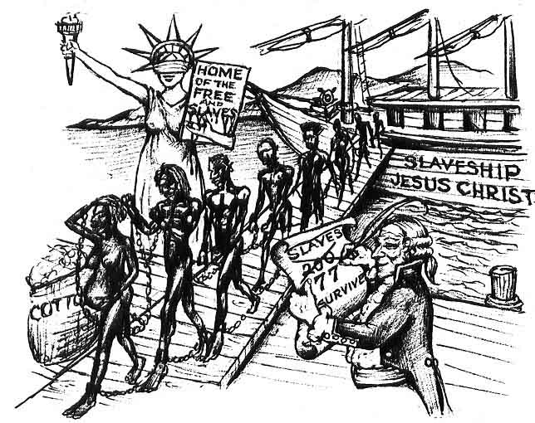
SLAVESHIP TO AMERICA
If there is one scripture that stands out as a living SIGN Of the accuracy of YAH’s WORD, it’s Deuteronomy 28:68*
Deuteronomy 28:68*And YAH shall bring THEE (ancient Nation of Yisrael) into EGYPT (House of Bondage) again with SHIPS (SLAVESHIPS!), by the way whereof I spake unto thee (the land flowing with MILK and HONEY, Exodus 33:3), Thou shalt see it (that good land) NO MORE AGAIN: and there (in AMERICA, Second Egyptian BONDAGE!) YE shall be SOLD unto your ENEMIES (the European Gentiles) for BONDMEN (Hebrew men slaves) and BONDWOMEN (Hebrew women slaves), and NO MAN (the United States of America is described as a BEAST! Revelations 13:11) SHALL REDEEM (BUY) YOU.
How great and wonderful is YAH. Only He could take the one thing that we as people were most ashamed of (SLAVERY!), and make it the single greatest PROOF that the SO-CALLED NEGRO must be the true descendants of the ancient Hebrew Yisraelites by the fact that we alone of all the Nations of the earth came to the Americas as SLAVES in SLAVESHIPS!
Can the so-called Jewish people pint to anywhere in their history of being sold into BONDAGE in SLAVESHIPS? NO! Well, if they don’t fit the PHROPHECY (slipper) which is the only infallible PROOF YAH left the world, can they in truth be His ancient people? THINK!
The whole world knows, for it is a matter of historical record, that this ONLY befell the so-called Negro. What other people on the face of the earth fits this amazingly accurate prophecy, but the so-called Negro of America?
Over a period of one hundred years, an estimated one hundred million souls of our Black Hebrew mothers and fathers died just en-route to the Americas, in the stinking, rotting hulls of these slave ships of death. These slave ships were always accompanied by sharks awaiting a free meal from one of the Hebrews who had died and were thrown overboard, or who had jumped to their death rather than face than face the living HELL of SLAVERY. This number (100 million!) doesn’t even include the countless number of souls who perished under the IRON JAWS of SLAVERY itself, in the “Belly of the BEAST!”
The size of this number really comes into focus when we realize a questionable 6 million Jewish people died over sixty years ago, and they, to this day, through their control of the media (television) won’t let the world forget their loss. Compare that to over 100 million of our true black Hebrew fathers and mothers perishing, yet no one cries out for their loss! But the Father, knows, that’s why He revealed the true HOLOCAUST in His WORD (…not on their TELEVISION).
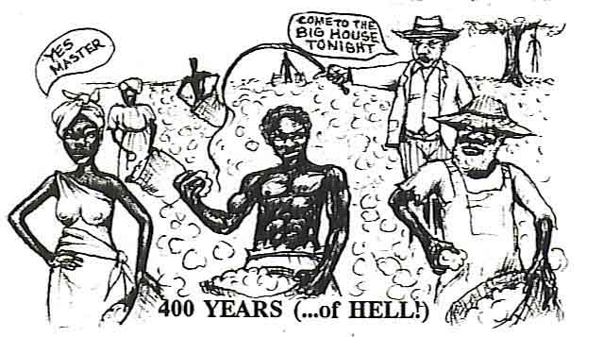
Why even the length of time of our captivity in the Americas is a matter of PROPHETIC RECORD, revealed to our father Abraham in a vision which stands as a SIGH for us today.

Genesis 15:13, 14 And He said unto Abram, KNOW OF A SURETY (CANT LIE!) that THY SEED(children of Yisrael) shall be a STRANGER in a LAND(America) that is not theirs, and shall SERVE THEM (as slaves); and THEY (America) that is not theirs, and shall SERVE THEM (as slaves); and THEY (America) shall afflict them…FOUR HUNDRED YEARS;
And also that NATION (America), whom they shall SERVE (as slaves) will I JUDGE (Destroy): and afterward shall they come out with GREAT SUBSTANCE (wealth).

Some might say this 400 years’ servitude refers to our first Egyptian bondage down in the land of Egypt. But this is disproved by the Bible itself which states the Egyptian bondage lasted 430 years not 400years.

Exodus 12:4 And it came to pass at the END of FOUR HUNDRED and THIRTY YEARS (430), even the self SAME DAY it came to pass that ALL the HOST OF YAH (children of Yisrael) WENT OUT from the LAND of EGYPT.

Seeing that YAH CAN’T LIE, when then does the 400 YEAR prophecy fit? Our ancient Hebrew forefathers in Egypt, or US, their descendants, the SO-CALLED NEGRO, serving our 400 YEAR captivity in America?
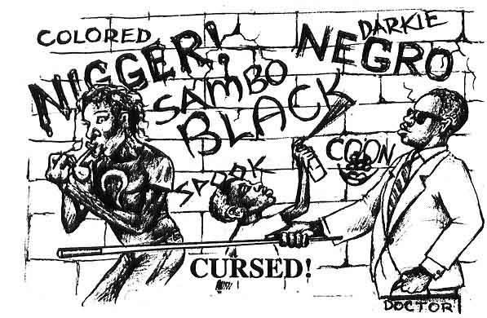

(“A Proverb and a Byword”)
Why even the names “Negro” and “Black,” and the other PROVERBS and BYWORDS used towards the so-called black IDENTIFIES them as the NATION prophesied to suffer the CURSES signified as punishment towards the ancient Yisraelite Nation from YAH due to their disobedience to the Fathers Laws. YAH reveals that among other NATIONS of the world, such as the French, English, Egyptian, Ethiopians, etc., His NATION YISRAEL was to become a “PROVERB and a BYWORD.”

Deuteronomy 28:37 And thou (Yisrael) shalt become an ASTONISHMENT a PROVERB and a BYWORD, among ALL (other)NATIONS whither YAH shall lead thee.

Turn to it in your Bible and read it for yourself. Who else fits this prophecy? You don’t have to believe me. Just put the book down for a minute and go out and ask the first brother or sister you meet, “What Is your Nationality?” The answer you receive is proof enough we are the only people who fit this prophecy.
Ask the average SO-CALLED Negro his NATIONALITY (Nation), and he will give you such answers as African-American, Black, Negro, American, Indian, West Indian, Muslim, Mississippian, etc. Note that all of these PROVERBS, and BYWORDS, are incorrect for they don’t show his NATION. Nations are determined by LAND, LANGUAGE, and CULTURE (not just color). For example, ask an Italian his Nationality (Nation), he isn’t going to say WHITE (a color), or EUROPEAN (a continent), or CATHOLIC (a religion). He will say my NATIONALITY (Nation) is Italian; meaning he is from the Nation of Italy (LAND), he speaks Italian (LANGUAGE), and he might eat spaghetti or whatever Italians customarily do (CULTURE). The same thing applies to the English, French, Germans, Egyptians, Ethiopians, and ALL OTHER NATIONS, except YAH’s CHOSEN NATION of Yisrael (Yisraelites), who were to be CURSED! Not to know their LAND (Yisrael) LANGUAGE (Hebrew), or CULTURE (the Holy law and Commandments of YAH).
For those brothers and sisters who believe their Nationality is American, we would remind them that America is a Nation that consists of MANY NATIONS. For example, you can be a GERMAN American, ITALIAN America, ETHIOPIAN American, etc., but the only true original Native Americans are the Indians.
If we only knew YAH’S WORD, and would just stop for a minute and THINK, we would see that we are the only people on earth to fit the PROPHECIES (“glass slipper”) of the Bible. Every other people on earth knows his or her NATIONALITY except the SO-CALLED NEGRO.

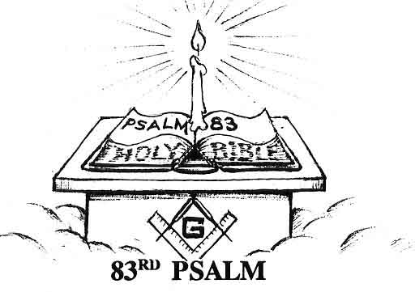
THE INTERNATIONAL CONSPIRACY
If you have not gotten a Bible up to this point to substantiate for yourself these amazing PROPHECIES, you must STOP NOW! Go get a Bible, for what we will reveal in the rest of this work is so vital a KEY in unlocking the TRUE IDENTITY of the SO-CALLED NEGRO, it was installed as a LIGHT in a SECRET MASONIC ORDER.
The 83RD PSALM, one of the mystic lights used by the secret Masonic order, reveals the HIDDEN TRUTH that the SO-CALLLED NEGRO has been the victim of a WORLD WIDE CONSPICRACY on the part of the Gentile Nations to keep him from the KNOWLEDGE of his TRUE NATIONAL IDENTITY!
Being an artist and a student of the Bible, I was fascinated to learn that through the SECRECT MASONIC CODE OF GEMATRIA (G), one could communicate by means of colors, numbers, and symbolic language hidden in pictures seen by all, but only understood by the few who possess the KEYS to this KNOWLEDGE.
Many years back, for example, I remember my first opportunity to view a Masonic Bible. In it was a painting displaying many of these symbolic images used by the craft. The one that stuck out in my mind though was a picture of a podium with a lighted candle on top of an open book with the Roman numerical (Latin) inscription written in the book, “Psalm 83” This picture obviously represented a key light in the secret Masonic order. It wouldn’t be until years later however, when I came into the TRUTH, that I would fully understand the deep, hidden (Masonic) message behind that picture. For those who are seeking the TRUTH, never, never, never, forger the 83rd PSALM
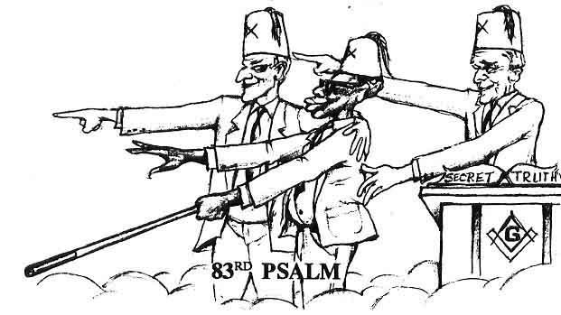
Psalm 83:1-6 Keep not thou silence, O Elohim: hold not thy peace, and be not still, O Elohim (Don’t just look and not speak out, or act upon this injustice).
For, lo, THINE ENEMIES (Heathen Nations) make a tumult: and they that HATE THEE have LIFTED UP the HEAD (gotten Dominion in the earth Genesis 27:40).
They(Gentile Nations) have taken CRAFTY COUNSEL (secret Masonic order) against THY PEOPLE(Nation of Yisrael), and CONSULTED (conspired) against thy HIDDEN ONES (the Lost Sheep of the House of Yisrael).
They (THE WORLD CONSPIRATORS) have said, come, and let us CUT/THEM OFF from being a… NATION; that the NAME of YISRAEL may be NO MORE in REMEMBRANCE (today the so-called Negro has totally forgotten who he is).
For they have CONSULTED TOGETHER with ONE CONSENT (E Pluribus Unum = “Out of many Nations…ONE NATION”: This is the Latin inscription found on the Great Seal of the United States of America): they CONFEDERATE against THEE (the SO-CALLED NEGERO The LOST SHEEP OF YISRAEL):
The TABERNACLES (religions)of EDOM (so-called Jewish IMPOSTERS), and the ISHMEELITES (founders of the ISLAMIC RELIGION); of Moab, and the Hagarenes (other ancient East African nations);

The list of these conspirator Nations goes on. Turn to this amazing prophesy and read it for yourself. What other Nation has been the victim of a WORLDWID CONSPIRICY to keep them from the knowledge of their TRUE IDENTITY?
This international conspiracy, used as a key light in the SECRET MASONIC ORDER, would also explain why our so called Negro leaders have failed to reveal the SECRECT of our TRUE IDENTITY! It is no coincidence that most of our leaders (especially preachers and politicians) are Masons, if you don’t believe me, just look at Ebony magazine’s list of the top 100 most influential Colored, Negroes, Blacks, African-Americans, etc., and notice how many are politicians, or grand head potentate of some secret fraternal lodge or order.
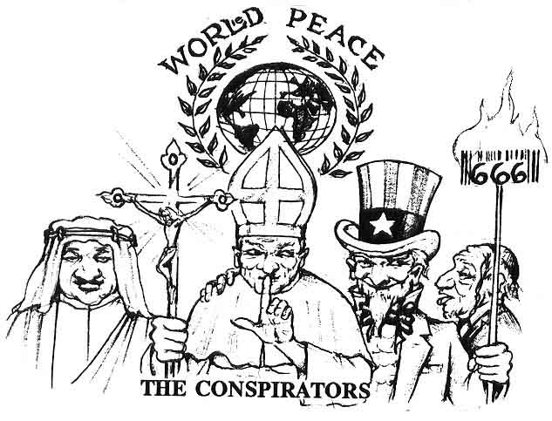
Understand that it was vital to the continued SURVIVAL of the Gentile world system to UNITE in a CONSPIRACY to destroy and keep the true Yisraelites (the so-called Negro) from the knowledge of their TRUE IDENTITY! It was only after the destruction of the ancient Nation of Yisrael that the Gentile Nations first got a hold of their sacred writings, called today the Holy Bible. With true black Yisrael in captivity, these Gentile Nations quickly laid claim to their history (Bible) for themselves. Today, the world’s three major religions (CHRISTIANITY, JUDAISM and ISLAM) all stake claim to the Hebrew scripture as the foundation for their religions, knowing full well it did not belong to any of them.
Now, if each of these three religions claims the Bible as its basis, knowing it only truly belonged to the Hebrew Nation, then from what Nation did these religions really come from? In the next section we will uncover the CONSPIRATOR NATIONS that are the real root of Christianity, Judaism, and Islam, which together have kept true Yisrael from rising.
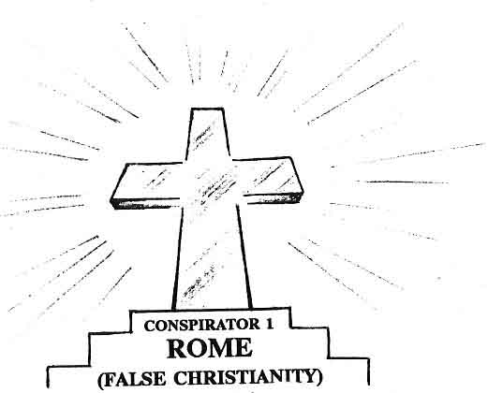
Most people believe the Christian religion we have come to know today was begun with the death and resurrection of the Messiah in 30 A.D. Unfortunately that is WRONG! Few realize the religion has NOTHING to do with the true Biblical Messiah YAHSHUA, but rather takes its ROOTS directly from the old BABYLONIAN MYSTERY RELIGION (it started at the Tower of Babel, Revelation 17:5), and eventually crept into the church at ROME in 312 A.D., long after the death of the Messiah.

WARNING!
(DON’T BE CONNED!)
Matthew 24:4,5 And Yahshua answered and said unto them, TAKE HEED (WARNING) that NO MAN DECEIVE (CON) YOU.
For MANY shall come in MY NAME (CHRIST), saying, I am Christ (CHRISTIAN); and shall DECEIVE MANY (the masses).

Revelation2:13 I (Yahshua) know thy (the false Christian church) WORKS(Satanic), and where thou dwellest (ROME), even where SATAN’S SEAT (earthly throne) is (modern-day Turkey): and thou holdest fast MY NAME (CHRIST)…
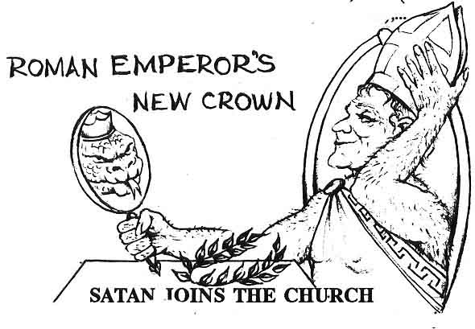Satan utilized the old adage, “If you can’t Beat ‘em, join ‘em.” Unable to destroy the true church of Yahshua by murder, torture, and persecution, SATAN JOINED THE CHURCH!
History records that in 312 A.D., the Roman Emperor Constantine (Satan’s then ruler of the world), JOINED the Christian religion, and in a few years transformed the entire pagan Roman Empire into a CHRISTIAN EMPIRE, called the HOLY ROMAN EMPIRE. Or should I rather say the simple persecuted true church of the Messiah Yahshua was transformed overnight into the idolatrous church of Rome, whom the scriptures call the BEAST!
To unify and appease his subjects, Constantine introduced all of the pagan ROMAN (Babylonian) worship into the church service, replacing the COMMANDMENTS revealed by the WORD of YAH. Examples of these changes can be noted on the
PAGAN ROOTS OF CHRISTIANITY
The Roman Emperor now became the Pope of Rome.
(No Biblical justification)
YAH’s 7th day Sabbath now became SUN (god’s) 1st day worship.
(No Biblical justification)
YAH’s Passover now became Eshtar/Easter (the MOON Goddess) day. Complete with rabbits, eggs, etc.
(No Biblical justification)
The SUN GOD’S birthday Celebrated by all heathen Nations on Dec.25th to Jan.1st, with pagan Symbols as Santa Claus, Reindeer, elves, mistletoe, now became called CHRISTmas.
(No Biblical justification)
Heathen’s IDOL TREE (Jeremiah 10:1-6) now became CHRISTMAS TREE.
(No Biblical justification)
BASILICAS (huge castles) now became CHURCHES.
(No Biblical justification)
Yahshua the Messiah now became (Je) ZEUS the Christ.
(No Biblical justification)
The Babylonian TAW now became the Christian CROSS.
(No Biblical justification)
The COMMANDMENTS now became DONE AWAY WITH!
(Misinterpretation of Bible)
It has been taught that Yisrael’s FUTURE GLORY now somehow became fulfilled in the Christian Church.
(No Biblical justification)
Note: SUN WORHIPPERS at the Tower of Babel observed that during the winter months daylight hours were getting shorter and shorter, assumed their SUN GOD was dying. Noticing that from Dec. 25th to Jan. 1st the days began to lengthen again, they celebrated the BIRTHDAY (or RE-BIRTH) of the baby SUN GOD, and a new SUN YEAR on those days, long before the birth of the Messiah. Refer to Jeremiah 10:1-6, to see what YAH thinks of this SUN WORSHIP called today CHRISTMAS!
These facts can be easily verified by looking up Christmas, Easter, Constantine the Great, the council of Nicaea in any good encyclopedia and you’ll discover the true roots of today’s Christianity. ROME simply DIED as a MILITARY POWER, only to rise again an even greater RELIGIOUS POWER, the mighty HOLY ROMAN EMPIRE (Roman Catholic Church).
Revelation 14:3 And I saw one of his HEADS (Roman Empire) as it were wounded to death (DIED!): and his DEADLY WOUND was HEALED the REVIVED HOLY ROMAN EMPIRE): and the world wondered after the BEAST (false Christianity).
The most damning change of all though, was the blasphemy of these conspirators to portray the true BLACK MESSIAH…as EUROPEAN! With this false Gentile image (IDOL) now circulating in churches, books, movies, homes, etc., the minds of the whole world have been thoroughly WHITE WASHED to believe a DAMN LIE!
The success of this conspiracy of Rome is seen in the fact that the true Hebrew slave, now reduced to a pig eating Negro who worshiped the Greek, blond, blue eyed god (Je ZEUS), would never in his wildest dreams imagine, in his quest for identity, he was the ORIGINAL JEW (of the Royal Tribe of Judah)…he was the wrong color.
But even worse than these brain washed Negroes are those of our people who can see through the FALSE EUROPEAN IMAGE, LIES, and HYPOCRISY of the false Christian church only to fall victim of making the fatal mistake of throwing away the BIBLE (their history book) along with false Christianity. Such terms as “That’s the white man’s book,” “I don’t deal with no fag King James Version,” or “The Bible has been tampered with,” are today acceptable cover-ups to being willfully ignorant of the TRUTH, the WORD OF YAH the greatest African document ever written.
First of all, we must understand when the original Hebrew Bible was being written by our Hebrew African fathers, the Japhetic tribes of Europe were barbarians who could neither read nor write. This means their existed original Hebrew manuscripts before England, France or Germany became a nation. Brothers who read Hebrew verify that the King James Version of the Bible is an authentic translation from the original Hebrew.
Secondly, King James didn’t write the King James Version of the Bible. What King James, the King of England did, was to, in 1603 A.D. , appoint the most learned Biblical scholars of England to produce an English translation from the original Hebrew (Old Testament), and Greek(New Testament) texts. It is because of this English translation we are even able to read and understand YAH’s WORD at all. It just confounds me when I hear blinded brothers and sisters in their ignorance, reject the only thing that is truly theirs, the HOLY BIBLE, written by their ancient Hebraic forefathers. This just goes to show you the amazing success of these conspirators.
Don’t be a fool, my people. Don’t throw away your only true SAVIOR, the WORD OF ALMIGHTY YAH, because the false Roman Church has deceived the whole world (Revelation12:9) through their FALSE IMAGES (painting the Messiah as a EUROPEAN GENTILE), their FALSE HOLIDAYS (Christmas, New Years, Easter, etc.) and their FALSE DOCTRINES (such as teaching YAH’s commandments are done away with). Learn to know the difference between RELIGION (the LIE!),and the WORD of YAH (the TRUTH!) Throw away the LIES (RELIGION), but keep His sacred WORD! In fact, only the knowledge of what the BIBLE (the greatest of all ancient documents) truly says, will force the false church to recognize the AFRICAN ORIGINS of the Book, and your rightful claim to being the true people of that Book.
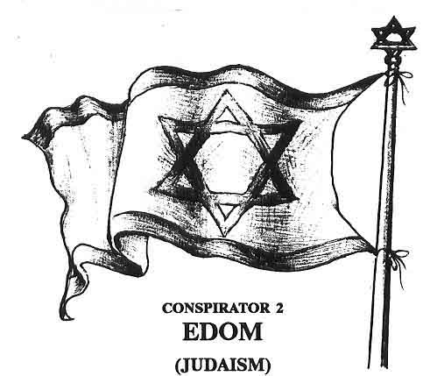

Revelation 3:9 Behold, I will make them of the SYNAGOGUE OF SATAN, say they are JEWS (Jewish people) and ARE NOT, but do LIE; behold, I (YAH) will make them (IMPOSTERS) to come and worship before thy (TRUE BLACK YISRAEL’S) feet, and to know that I have loved thee.

Going back to the 83rd Psalm, we remember it was the TABERNACLES (Religions) of EDOM (verse 6) who headed the list of conspirator NATIONS that conspired against YAH’s chosen Nation YISRAEL. You must understand, to uphold Rome’s GREAT WHITE LIE of portraying the true black Yisraelite Messiah, Yahshua, as a European, a NATION had to now be substituted to play the role of the true Jew. But what Nation would be so bold, so knowledgeable, to be able to DECEIVE THE WHOLE WORLD? If you guessed EDOM, you are absolutely correct. But who exactly is this EDOM?
All Nations today can be traced back to their ancient roots in the Bible. Some of these ancient Nations that appear in the Bible are still recognizable to us today, as the Egyptians, Ethiopians, Assyrians, and later the Greeks and Romans, etc. Other Nations that appear in the Bible are not so recognizable, as in the case of the Palestinians being the distant descendants of the ancient Philistines. Yet for others, it is vitally important to keep their true identity TOP SECRET, for if the world knew their real identity, they could not continue in their diabolical scheme to deceive the world. This is the case with EDOM. It is as important to these world conspirators to keep EDOM’S true identity, top secret, as it is for them to keep the so-called Negro’s identity hidden. In fact, as we shall soon see, these TWO NATIONS (EDOM, and YISRAEL, the so-called Negro) are inseparably linked, even from their beginnings. (The WOMB!).
Genesis 25:23 And YAH said unto her (Rebecca), TWO NATIONS (Edom and Yisrael) and are in thy WOMB, and TWO MANNER (opposite) of people shall be separated from thy bowels: and the one people (true BLACK YISRAEL) shall be stronger than the other people (EDOM); and the ELDER (ESAU or EDOM) shall serve the younger (JACOB or YISRAEL).
Genesis 25:25 And, the first came out RED, all over like an HAIRY GARMENT; and they called his name ESAU.
Now we go on to learn that ESAU dwelled in EDOM.
Genesis 36:8, 9 Thus dwelt ESAU in Mount Seir ESAU is EDOM.
And these are the generations of ESAU the FATHER of the EDOMITES in Mount Seir.
Note: ESAU=EDOM=EDOMITES=IDUMEAN= all the same.
It is important to understand that Esau and Jacob were twins but OPPOSITES. One NATION (Yisrael) represents YAH, and one NATION (Edom) represents (SATAN). YAH LOVES one (JACOB) and HATES the other (ESAU).
Malachi 1:2,3 I (YAH) LOVED JACOB (Yisrael) an HATED ESAU (Edom)…
History records that the Nation of EDOM (called by the Greek and Idumeans) were ancient Yisrael’s bitterest enemy. The little book of Obadiah in the Bible, details Edom’s treachery against Yisrael. While Yisrael was fighting for its very life against the Roman Empire, Edom joined with Rome in the defeat of Yisrael. After the survivors were driven out, Edom slipped in and took possession of their land, and even assumed their IDENTITY.
Obadiah 1:6-11,13 How are things (SECRECTS)
of ESAU...SEARCHED OUT! How are his HIDDEN things SOUGHT UP!
In the day that thou stoodest on the other side (with the Euro-Gentile Nations), in the day that the strangers (the ROMAN EMPIRE) carried away captive his Yisrael’s) FORCES (armies), and FOREIGNERS entered into his GATES (land of Yisrael),and CAST LOTS ON (divided up) JERUSALEM, even thou (EDOM) was one with them.
Thou shouldest not have entered into the GATE of MY PEOPLE in the day of their CALAMITY; yea thou shouldest not have looked (TOOK ADVANTAGE) on their AFFLICTION in the day of their CALAMITY, nor have laid hands on (STOLEN) their (Yisrael’s) SUBSTANCE (land, language, culture, history...IDENTITY) in the day of their calamity (DESTRUCTION!);
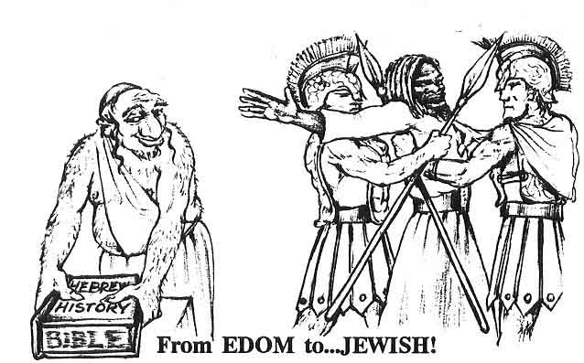It
It is a little known, but well documented fact, that Edomites at the time of the destruction of Jerusalem by Rome, were already practicing CIRCUMCISION, and observing all of the HEBRAIC LAWS (just look up EDOM in any Bible dictionary an read their history). This came about many years earlier when Yisrael’s High Priest, John Hyrcanus of the Maccabee’s, had conquered Edom and forced them to submit to all the Hebraic laws including circumcision or suffer expulsion from the region. Rather than face expulsion from the region. The whole (“red and hairy”) Nation chose to CONVERT (this was in effect the beginning of what is today called the JEWish RELIGION). Josephus, Book 13, chapter 9, section 1 The following is taken from Unger’s Bible dictionary under the heading “EDOMITES”:

“But during the warlike rule of the Maccabees they (Edomites) were again completely subdued, and even forced to conform to JEWISH (Hebrew) LAWS and RITES and submit to the government of Jewish prefects. The EDOMITES were now incorporated with the Jewish (HEBREW) Nation, and The whole province was often termed by the Greek and Roman writers Idumaea. Immediately after the siege of Jerusalem by (The Roman writers Titus, twenty thousand Idumeans were admitted to the Holy City, which they filled with ROBBERY and BLOODSHED. From the time the EDOMITES, as a separate, people, disappear from the pages of history (...they became JEWISH!).”
With true BLACK YISRAEL driven from their land, EDOM (Esau) just slipped in and assumed their IDENTITY. Today, after some two thousand years, the whole world including the SO-CALLED Negro) has been DECEIVED to just assume without PROOF that these EDOMITES (Idumeans) and their European converts are the original descendants of the ancient Yisraelite Nation.
Today through the massive power JEWish (like a Jew) people exact over mass media they have been successful in labeling anyone that would question their claim of being the true descendants of the ancient Yisraelites as anti-Semitic, racist, cult, hate teachers, etc., in an effort to divert world attention from the real question at hand, “Where is the Biblical proof to their claim of being the true Jews?”
Though they can claim hundred of years of JEWish, tradition in Europe, numbers of European converts, wealth and power, plus military occupation of the Holy Land, etc., etc., we challenge all of their learned rabbis, scholars, historians, etc., to produce the SCRIPTURAL EVIDENCE to support their false claim. The fact is they won’t, because they can’t. For the simple reason they aren’t the DARK SKINNED, WOOLY HAIRED peoples whose forefathers who fit the BOOK, but are in plain truth IMPOSTERS, whose forefathers converted so many years back that they have just come to assume without proof they are the chosen people.
Our claim is based on the BIBLE (THE WORD), which can’t be accused of being anti-Semitic, a cult, or hate teacher.
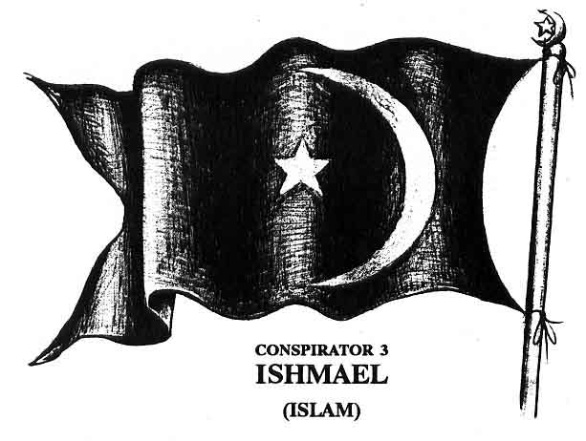
As we are now seeing, the destruction of the ancient Nation of Yisrael opened the door of many (heathen Nations) to seize upon their history (Holy Bible), to justify their own false religions. As the 83rd Psalm has revealed, the ISHMAELITES were secondly only to Edom in the list of conspirator Nations.
The ISHMAELITES were a Nation that were the descendants of Abraham’s first born son ISHMAEL, by (his wife) Sarah’s Egyptian handmaid, Hagar.
Genesis 16:11,12 And the Angel of YAH said unto her (Hagar), Behold, thou art with child(of Abraham), and shalt bear a son and shalt call his name ISHMAEL; because YAH hath heard thy affliction.
And he (Ishmael) will be a WILD MAN; (religious fanatical) his hand will be against every man, and every man’s hand against him; and he shall dwell in the presence of all his brethren (in the wilderness desert areas of Northeast Africa).
Genesis 17:20,21 And as for ISHAMAEL, I have heard thee (Abraham’s request): Behold, I have blessed him and will make him fruitful, and will multiply him exceedingly; twelve princes shall he beget ad I will make him a ...GREAT NATION!
But MY COVENANT will I establish with ISAAC (...NOT ISHMAEL), which Sarah shall bear unto thee at this set time in the next year.
Ishmael did become a great Nation in the East noted for being nomadic merchants, famous for their great caravans which traded in everything from SLAVES to spices. It was ISHMAELITE merchants for example, who bought Joseph for twenty pieces of silver and brought into SLAVERY in Egypt (sound familiar?).

Genesis 37:28 Then there passed by Midianites merchantmen; and they drew and lifted up Joseph out of the PIT (where his brothers had thrown him), and SOLD Joseph out of the PIT (where his brothers had thrown him). And SOLD Joseph to the ISHMEELITES for TWENTY PIECES of SILVER: and they brought Joseph into Egypt (BONDAGE!)
Ishmaelites were named as one of the principle conspirators (PSALM 83:6) for their role in the GREAT SLAVE TRADE caravaning HEBREW SLAVES to the waiting European slaving ports in West Africa.
Many of the prophecies we have read concerning Ishmael’s future greatness are fulfilled in the world wide impact of ISLAM, the second largest religion on earth. The Islamic religion was founded by the prophet Mohammed, who claimed to be a direct descendant of Ishmael. Tenants of the Islamic faith teach true Yisrael was CUTOFF, and the promises given to Isaac were now conferred upon Ishmael, being Abraham’s first born son. There is however, no Biblical support for this doctrine.
One interesting note about these THREE RELIGIONS (especially when they address the so-called Negro): they always use the HOLY BIBLE (not the Koran, or Roman, or Greek mythology), knowing that YAH’s people will only respond to the SPIRIT of YAH’S WORD, but in closing they won’t give YAH the glory, but give to ALLAH, (Je)ZEUS, GAD/GOD, etc.

NATION...of RELIGION?
For example, the late Elijah Muhammad (Born Elijah Poole, 1897) seeing the wretched, ignorant, impoverished condition of his beloved people, founded the Nation of Islam. Being a student of the Bible and recognizing the amazing similarities that existed between the so-called Negro’s condition and that of the ancient Nation of Yisrael, but astutely realizing that it was not time for the HOLY BIBLE, the Koran was used only sparingly. For example, instead of teaching we were the, “lost-found Nation of Yisrael” as the Bible teaches, he switched it to the “lost-found Nation of Islam.” Despite the strong Biblical teachings, in closing, glory was to ALLAH and the Prophet Muhammad, instead of YAH and Prophet Yahshua. This concept of NATIONHOOD awakened a spark of light in the so-called Negro’s darkened consciousness. The movement, commonly called the BLACK MUSLIMS, grew to be one of the greatest forces for the uplifting of the so-called black man and woman in America.
After Elijah Muhammad’s death however, his son, Wallace Muhammad, established the American Muslim Mission, in an attempt to shift the movement away from the Bible and the black Nationalistic teachings of his father, towards orthodox Islamic religion and the Koran. He failed to grasp that the charm that had built his father’s movement, as well as the appeal of such men as Marcus Garvey, Malcolm X, Bob Marley, etc., was their call for NATIONHOOD! Subsequently, the American Muslim disbanded in 1985. Louis Farrakhan went with the winning combination of his teacher, Elijah Muhammad, teaching NATIONHOOD from a strong base in the BIBLE and is still going strong today. It will be interesting to see the role that the black (Hebrew) Muslims will play in the near future, as the Spirit of YAH is going forth in these last days to RAISE UP his ancient people to the FULL KNOWLEDGE of their TRUE NATIONAL IDENTITY (ancestry, land, language, culture) being the NATION of YISRAEL (...NOT A RELIGION).
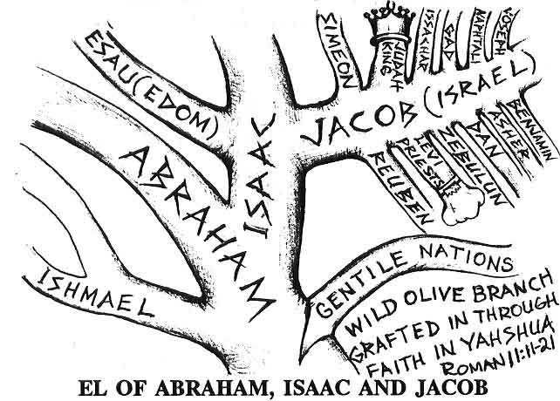
After reviewing this section of the CONSPIRATORS and their FALSE RELIGIONS, we can now see why when Moses asked, “What is His name?” YAH said, more over unto Moses ”thus shalt you say unto the children of YISRAEL (His NATION!), YAH Elohim of your FATHERS, the El of Abraham, the El of Isaac, and the El of Jacob, has sent me unto you: THIS IS MY NAME...FOREVER, and this is MY MEMORIAL unto ALL GENERATIONS.” (Exodus 3:15)
Note He did not say, the El of Abraham, El of Ishmael, and El of Muhammad (Islam), nor did He say the El of Abraham, the El of Isaac, and the El of Esau (Judaism), nor did He say, the El of Greece, the El of Rome, and the El of (Je)Zeus (false Christianity). Because He knew these CONSPIRATORS would lay false claim to His people’s inheritance, as a MEMORIAL He said HIS NAME FOREVER is YAHWEH ELOHIM, the El of Abraham, the El of Isaac, and the El of Jacob (called the so-called Negro today)...a NATION (...NOT RELIGION!). It’s that simple.
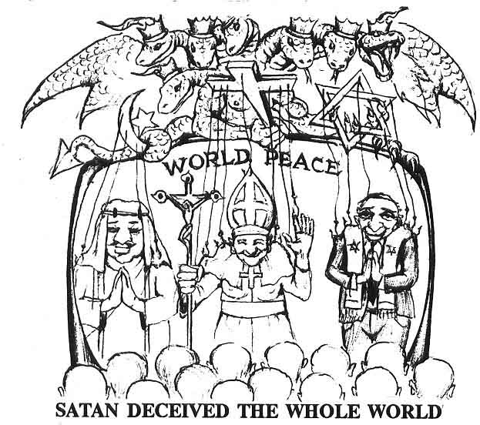
SATAN DECEIVED THE WHOLE WORLD
Through the efforts of these world conspirators; ROME (Christianity), EDOM (Judaism), ISHMAEL (Islam), the whole world has been deceived(...by RELIGION!). The Bible reveals the master mind behind this international conspiracy and deception is none other than that old wise SERPENT, the angelic being, called the DEVIL, and SATAN.
Revelation 12:9 and the GREAT DRAGON was cast out (of Heaven) that old SERPENT, called the DEVIL, and SATAN, which DECIEVETH THE WHOLE WORLD. He cast out into the earth, and his ANGELS (Demons) were cast out with him.
Have you ever hear the saying, “The many different religions in the world, are only different paths to the same GOD.” TRUE! But that GOD, the GOD of the RELIGION and NATIONS of this wicked WORLD SYSTEM is none other than SATAN!
Corinthians 4:4 In whom the GOD of this WORLD (Satan) hath BLINDED (DECEIVED) the MINDS of them which believe not (THE WORD)!
This is so vitally important for us to understand, that SATAN, ... NOT YAH, is the GOD of the (the Nations, religions, economics, politics, etc., of this wicked WORLD SYSTEM. For example, compare the popularly held view “ALL RELIGIONS are just different paths to the SAME GOD,” with shat the Bible actually teaches and you be the judge.
Matthew 7:13,14 ...BROAD is the WAY (Religion) that leadeth to DESTRUCTION, and many (the MASSES!) there be which go in there at.
Because SMALL is the GATE (Yahshua), and NARROW is the WAY (THE WORD of YAH), which leadeth unto LIFE (ETERNAL), and few (the Chosen) there be that find it.
John 14:6 Yahshua said unto him, I AM...the WAY,...the TRUTH, and the LIFE (remember he was the WORD of YAH John 1:1,14): NO MAN cometh unto the Father (YAH), but by ME (HIS SAVING WORD...NOT RELIGION!)
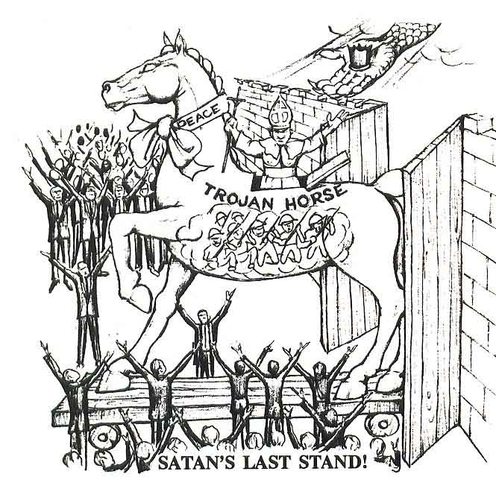
Understand that as the WORD of TRUTH (the TRUMPET) is being sounded to raise up TRUE YISRAEL and open their eyes to their rightful BIRTHRIGHT (Daniel 12:1), Satan will RAGE knowing that he has only a SHORT TIME to deceive the Nations.
Revelation 12:12 WOE to the inhibitors of the earth and of the sea! For SATAN is coming down unto you having GREAT WRATH, because he knoweth that he had but a...SHORT TIME!
The Bible further WARNS that Satan soon will UNITE ALL NAITONS (United Nations) and RELIGIONS under the revived ROMAN EMPIRE (the European Union) establishing NEW ONE WORLD ORDER, called in scriptures the BEAST!(Revelation 13:1-9) The head of this order, will move to Jerusalem to establish WORLD PEACE, guaranteeing ALL RELIGIONS (Christianity, Judaism, Islam, Buddhism, etc.) and NATIONS the” freedom to worship” the GOD (Je Zeus, God, Allah, Buddha...all SATAN) of their choice as long as it’s not according to the SPIRIT of the WORD of YAH! Further information of the BEAST, is covered in our book, “MARK of the BEAST! Dream, or Nightmare.” Learn of the amazing events revealed in YAH’s WORD which will usher in the end of this age.
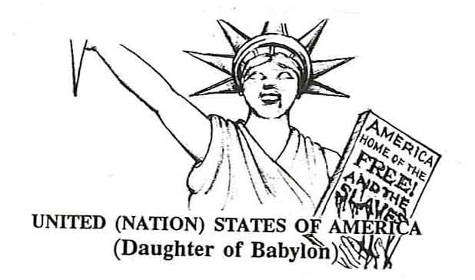
As important as it is for us to understand the WORLDWIDE INTER (NATION)AL CONSPIRACY to keep the SO-CALLED NEGRO from his TRUE IDENTTIY, it is equally important for us to understand the SYSTEM and LAND where this conspiracy actually took place.
It never ceases to amaze me how so-called Biblical scholars can find every little poot-butt, second rate Nation in the Bible, but when it comes to finding the leading power in the world in these last days, the United States of America, they all of a sudden get a case of the stupids. It’s not that they cannot find her mind you, it is just that they are looking for her as some good righteous Nation. The truth is the Bible identifies the UNITED STATES of AMERICA as we have already seen as that wicked Nation to which the true BLACK HEBREWS were taken to serve their 400 YEAR CAPTIVITY (Genesis 15:13, 14) in SLAVESHIPS to serve their second EGYPTIAN BONDGE (Deuteronomy 28:68).
The United States of America is further identified in scripture as the wicked “Daughter of Babylon.”
The United States’ SYSTEM of rule is DEMOCRACY, from the Greek root word demokratia, meaning Demo “the people” and kratos “rule,” or “rule (government) of the people.” Contrary to what you have been taught to believe the Bible reveals over and over again governments elected by men are Satanic.
The story of King David’s handsome and well liked son, Absalom (II Samuel chapters 15-18), is one of the good examples of the lies and promises, that charming, hypocritical men will make to convert the hearts of men in order to get their vote to acquire power. If we look to scripture YAH (not men) always elects His leaders, based on their heart being willingly OBEDIENT to HIS WORD. These anointed individuals are often not people pleasing or even understood by men. This is why we read the PROPHETS and even the MESSIAH Himself, were rejected by men.
Contrary to what you have been programmed to believe, DEMOCRACY (“government ruled by the people”) has its roots as far back to BABEL, where the PEOPLE UNITE to build a TOWER (system) to reach into Heaven to thwart the rule of YAH.
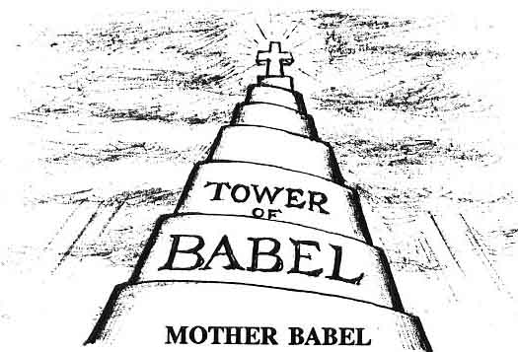
Genesis 4:6-8 And they (they people) said, Go to, let us build us a CITY (Kingdom) and a TOWER (government), whose top may reach unto Heaven; and let us make US a NAME (a UNITED NATION SYSTEM), lest we be SCATTERED abroad upon the face of the whole earth.
And YAH said, Behold, THE PEOPLE is ONE (E Pluribus Unum), and they have ONE LANGUAGE (communication); and this they begin to do: and now nothing will be restrained from them (to thwart His will), which they have imagined to do. So YAH SCATTERED them abroad from thence upon the face of all the earth: and they LEFT OFF (didn’t complete) to build the city (KINGDOM).
From that time YAH established NATIONS, GIVING EACH Nation their own LAND, LANGUAGE, CULTURE as an inheritance upon the earth. He chose the NATION of YISRAEL to represent Him, and be the head or ruling Nation on earth (Deuteronomy 28:13). The true Black ancient Nation of Yisrael was YAH’s SON (Exodus 4:22), created to show man the true way YAH desired for man to governed; by his DIVINE (not man made) laws and commandments, He gave them from Heaven. It’s simple. YAH rules from Heaven DOWN to earth through His chosen Nation, Yisrael, as opposed to a UNITED NATION (man made) rule on earth to reach UP into the Heavens to thwart YAH’s rule.
But as PSALM 83 illustrates, the gentile Nation’s goal was to conspire to get rid of the Nation of Yisrael, and establish their own UNITED NATION (STATE), to finish, in effect, where the builders of (mother) Babel left off. To establish a NEW ONE WORLD ORDER, a KINGDOM, without YAH’s King (Yahshua), or His Kingdom (Yisrael).
Psalm 83:5,6 They (GENTILE NAITONS) have said, come and let us CUT THEM OFF from being a NATION; THAT THE NAME of YISRAEL may be NO MORE IN REMEMBRANCE!
For they CONSULTED TOGETHER with ONE CONSENT (E PLURIBUS UNUM = out of many Nations, ONE NATION); they are CONFEDERATED (United States and United Nation) against thee (TRUE BLACK YISRAEL, YAH’s chosen NATION).

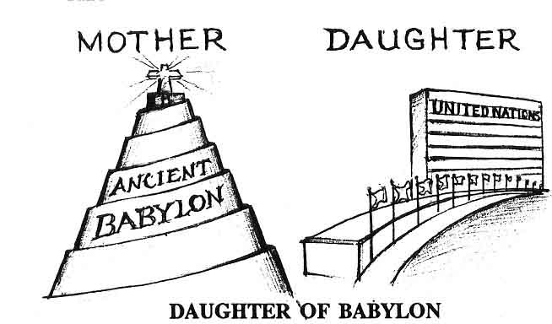

What other NATION fulfills these scriptures but the United States America? That is why she is identified in scriptures as the “daughter of Babylon.” Just like her mothers, the Kingdom of BABEL, and later Babylon the Great, she is not actually a NATION, but a REPUBLIC comprised of MANY NATIONS. And just like her mother, scriptures reveal the DAUGHTER also enslaved the Hebrews.
Isaiah 47:1-5,6 come down (FALL!) and sit in the dust, O VIRGIN(no foreign army invaded her shores) DAUGHTER OF BABYLON...(UNITED STATES of AMERICA)...for thou shalt no more be called the LADY OF KINGDOMS (America the beautiful).
I was WROTH with MY PEOPLE (true black Yisrael), I have POLLUTED (mixed their blood with other Nations) MINE INHERITANCE, and didst show them NO MERCY: upon the ANCIENT hast thou very heavily laid thy YOKE (slavery).
Psalm 137:3 For their (in the United States) they (the heathens) that carried us away CAPTIVE required of us a SONG (“We Shall Overcome”) and they that hated (DESTROYED) us required of us MIRTH (“don’t worry be happy”), saying sing us one of the songs of Zion (one of the old Negro spirituals). O DAUGHTER OF BABYLON (United States of America), who art to be DESTROYED (by NUCLEAR HOLOCAUST! Jeremiah 50:42-46); happy shall he be, that rewardeth thee as thou hast served us (TOTAL DESTRUCTION!)
We can see by these scriptures, the United States was DIVINELY established by YAH to PUNISH true Yisrael.

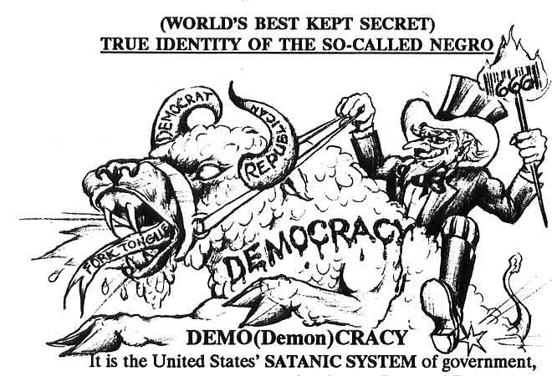
It is the United States’ SATANIC SYSTEM of government, DEMOCRACY, which is revealed in the Book of Revelation as the SYSTEM (BEAST) that would come up out of the earth (NATIONS) to DECEIVE THE WHOLE WORLD!
Revelation 13:11 And I beheld another BEAST (United States of America) coming up out of the EARTH (the Euro-gentile Nation): and he (U.S.A.) had TWO HORNS (two party DEMOCRATIC SYSTEM) like a LAMB (looks righteous), and he spake (LIED) as a DRAGON (forked tongued SERPENT!)
The Native Americans revealed the SERPENT LIKE NATURE of the United States DEMOCRATIC SYSTEM (SPAKE LIKE A DRAGON), in their saying “White man speaks with FORKED TONGUE.”
For example, the United States’ Declaration of Independence states “all men are created EQUAL, that they are endowed by their Creator with certain unalienable RIGHTS, among these are LIFE, LIBERTY, and the pursuit of HAPPINESS.”
Now at face value this sounds good(“looks like a LAMB”), but at the very time they were writing these eloquent words, they owned slaves”... spake [LIED!] like a [FORK TONGUED] DRAGON!” Revelation 13:11
One of the reasons we as a people have never advanced in America is due in large part to our not understanding the FORK TONGUE (double standard) of the United States’ system of government.
Deuteronomy 28:49, 50 YAH shall bring a NATION against tee from far (across the ocean), from the end of the earth (United States of America), as swift as the EAGLE (symbol of the USA) flieth; a NATION whose (fork) TONGUE thou shalt NOT UNDERSTAND.
A NATION of FIERCE COUNTENANCE, which shall not regard the person of the OLD, or show favour to the YOUNG:
Anytime a Negro (a “wanna be”) says he believes in America, he doesn’t realize what he is saying. Why, the name America itself is derived from the Latin root word AMERCE, which means to PUNISH!
While all other NATIONS (the English, French, Russian, German, etc.) came here on top of the ships into LIBERTY, you must never forget the SO-CALLED NEGRO came to the “land of the free” in CHAINS, shackled in the belly (BOTTOM!) of the ship. And after 400 years in this country, that’s where you’ll find us today... at the BOTTOM of the boat.
You do not have to believe us, or the overwhelming evidence found in scriptures. Proof that the founding (MASONIC) fathers of the Unite States of America knew only too well that their so-called Negro slaves were in fact the ancient Hebrew NATION, was revealed on something so common, we all carry it around with us every day. We do not stop to realize that the KEY to unlock the knowledge of who we are, is right under our very nose, on THE GREAT SEAL OF THE UNITED STATES, found on the face of every dollar bill.
The founding fathers, writers of the U.S. Constitution, were all 33 degree Masons who utilized the science of GEMATRIA in formulating the symbols that would come to represent the New Republic. Contained in those symbols (SEALS) are the keys to unlock the knowledge of who we are and the divine purpose for our coming to America
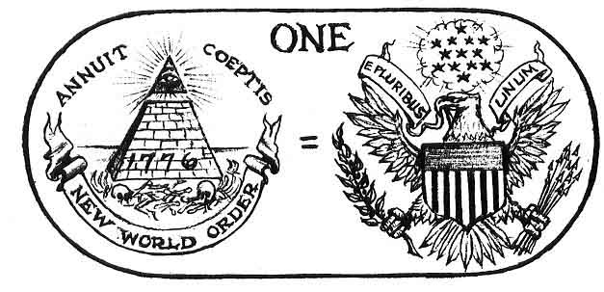
(THE GREAT SEAL)(OF THE UNITED STATES)
Just take out a dollar bill and read the words written under the two SEALS at the bottom (THE GREAT SEAL OF THE UNITED STATES). We can see by this that these TWO SEALS constitute the ONE GREAT SEAL of the UNTIED STATES, and to be understood should be read (INTERPRETED) together to bring out its true HIDDEN (GEMATRIA) MEANING.
Beginning with the seal on the right, we see an EAGLE which everyone knows is the symbol of the United States of America. In the EAGLE’S (U.S.A.) beak is a BANNER which reads in Latin “E PLURIBUS UNUM,” meaning OUT OF MANY (NATIONS) = ONE NATION. This shows that the United States is actually a REPUBLIC formed by a UNITY of many (Euro-Gentile) NATIONS. The EAGLE is a bird of prey (WAR). Unlike the LAMB (the symbol for the black Nation of Yisrael), which can live peaceably on grass, the EAGLE (U.S.A.) must KILL(...MAKE WAR) to survive. Her deceptive nature is to lull her innocent (IGNORANT) victims into a false peace, while all the time she is soaring high in the sky unseen to them below. This is represented by the symbolic OLIVE BRANCH in her right talon (she offers peace), but like the blood thirsty bird of prey she is, her real intent is WAR, as symbolized by the ARROWS in her left talon.
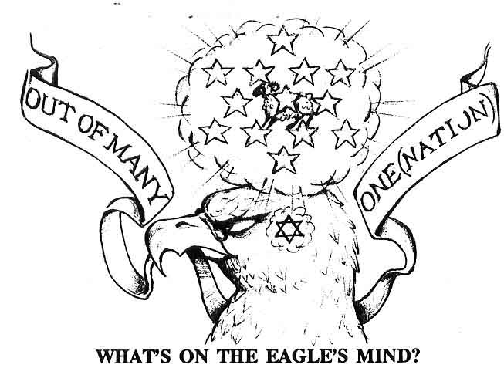
Over the EAGLE’S head on the dollar bill, is a haze, symbolic of thought. The Eagle is thinking about something very important, a valuable prey no doubt, one that is vital to its survival, inside the haze we find 13 STARS. Take a pencil and draw a line through each star and amazingly you’ll see these stars form the STAR OF DAVD, symbol for the NATION OF YISRAEL (YAH’s lamb.)
To further prove the founding Masonic fathers of this country knew they were blessed to be in possession of “YAH’s treasure,” the Hebrew slaves is seen in the next seal on the left. The Eagle is thinking of the NATION OF YISRAEL and looking at the PYRAMID (symbol of the old Egyptian BONDAGE) with the ALL SEEING EYE (symbol of Egypt) in the CORNER STONE. Over the eye are the words in Latin ANNUIT COEPTIS interpreted, “He (God) blesses our undertaking (to enslave the Hebrews).”
Finally the BANNER under the pyramid reads in Latin NOVUS ORDO SECLORUM interpreted “NEW” (Gentile) WORLD ORDER” What greater proof can you want, than the UNITED STATES’ own GREAT SEAL confirming everything we have shown you in scripture (Psalm 83, Isaiah 47, Psalm 137); that the United (NATION) States of America IS the “DAUGHTER of BABYLON, the SECOND BEAST that came up in Revelation 13; whom YAH had BLESSED (ANNUIT COEPTIS) to establish NEW WORLD ORDER, (NOVUS ORDO SECLORUM) out of a UNITY of MANY European Nations (E PLURIBUS UNUM), to punish true BLACK Yisrael, the one Nation the EAGLE (U.S.A.) is thinking about that came to her shores in CHAINS, to be the victim of the INTER(NATION)AL CONSPIRACY to make her captors the wealthiest Nation on earth.
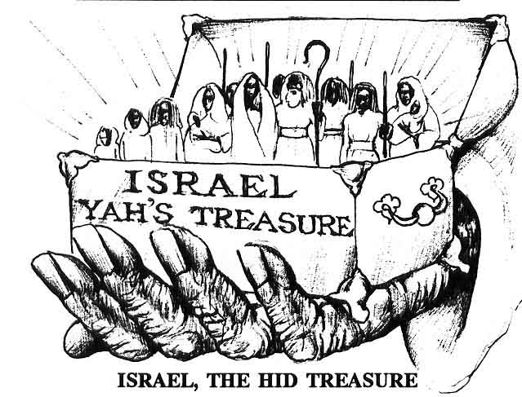
You must understand the great value to which the Most High places on his beloved people, YISRAEL. He states that of all the things on earth, YISRAEL is His TREASURE.

Exodus 19:5 Now therefore, if ye will obey My voice (THE WORD) indeed, and keep MY COVENANT, then ye shall be a PECULIAR TREASURE unto Me (YAH) above all people (Nations): for all the earth is Mine.

History records that whoever possessed Yisrael (YAH’S TREASURE) would ultimately rule the world. For example, when we were in captivity in Egypt, she ruled the world. When Yisrael was taken captive into ancient Babylon at the time of the prophet Daniel, Babylon ruled the world. Today we can see why the EAGLE (U.S.A) is thinking about her Yisraelite slaves (THE HID TREASURE), and the high price she puts on keeping us from our ROYAL BIRHTRIGHT!
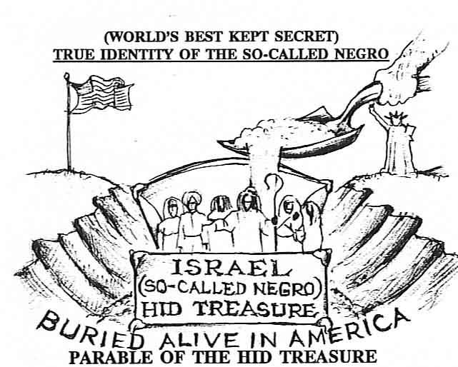
Many of Yahshua’s teachings are not easy to understand because He often spoke in PARABLES. This was to hide the true meaning from all but His true followers.

Matthew 13:10, 11 And the DISCIPLES came, and said unto Him, Why speakest thou unto them (the people) in PARABLES?
He answered and said unto them, because it is given unto you (the true followers of THE WORD) to know (UNDERSTAND) the MYSTERIES of the Kingdom of Heaven, but to them (unbelievers) it is not given.
This is why many people have trouble understanding the New Testament. But when He reveals to us the meaning of these PARABLES through the help of the HOLY SPIRIT (Spirit of Truth Matthew 14:26 & 16:13), amazingly it reveals the same CONSPIRACY against YISRAEL as other scriptures have revealed.
Matthew 13:44 Again, the KINGDOM OF HEAVEN (the term used to define the history that would transpire on earth, before the Messiah would return from heaven in glory) is like unto TREASURE (Nation of Yisrael, Exodus 19:5) HID (BY YAH, Isaiah 49:2,3) in a FIELD (the world, Deuteronomy 32:26) the man which when a MAN (GENTILE NATIONS under divine guidance) hath FOUND, he HIDETH (Buried us in America, Deuteronomy 28:68) and for joy thereof goeth and SELLETH all that he hath (in Europe, the OLD WORLD), and BUYETH (invest in) that FIELD (United [NATION] States of America, the NEW WORLD).
Can you think of another Nation buried (HID) inside of a Nation, so rich in spirit, talent, and strength, which has made its captors the wealthiest Nation in the world other than the so-called Negro?
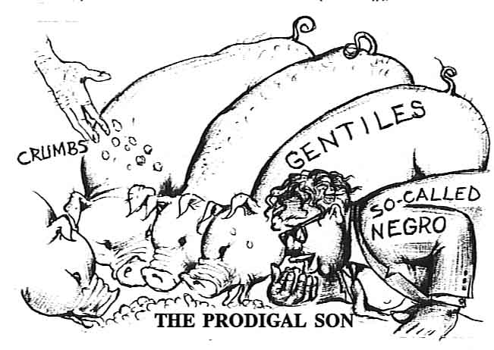
Who better fits the parable of the PRODIGAL SON (Luke 15:11-32) than the SO-CALLED NEGRO (the LOST SHEEP of YISRAEL)? In this parable the YOUNGER SON (symbolic of YISRAEL, Isaac’s younger son) didn’t appreciate the INHERITANCE he had received from his FATHER (Symbolic of YAH), but had wasted it on RIOTOUS LIVING (Deuteronomy 32:15). Next he took a journey into a FAR COUNTRY (Gentile Nations) where their arose a FAMINE (Symbolic of tribulation of Yisrael) so being in want he JOINED A CITIZEN of a LAND (tried to become a Gentile), who sent him into his FIELD (America) to feed PIGS (Symbol of Yisrael’s LOWEST ESTATE). It says he would have eaten the garbage he fed the pigs and NO MAN (...NO NATION) helped him. What is this but a prophetic view of Yisrael in the WRETCHED CONDITION he finds himself in today, reduced to a PIG EATER.
But it says when he CAME TO HIMSELF (...WOKE UP), he REPENTED and AROSE (...STOOD UP) and went to his wealthy FATHER (Almighty YAH), and said “I have SINNED (transgressed your Law, 1 John 3:4) against Heaven and am no more worth to be called THY SON (Yisrael, Exodus 4:22).”
His FATHER (Almighty YAH) says, “This is MY SON (Yisrael is My Son, Exodus 4:22) was DEAD (...IGNORANT) and is ALIVE AGAIN (came to his senses). He was LOST (from his El), but now is FOUND.
What Nation on earth fits this PARABLE (slipper), but the SO-CALLED NEGRO?
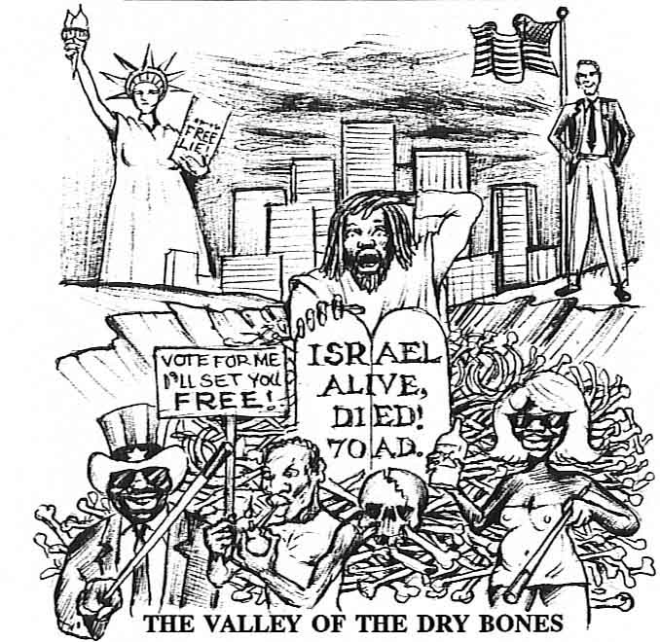
It is going on two thousand years now that we have been away from our ancestral homeland, YISRAEL, in Northeast Africa. The many years of wandering, the slave trade, the conspiracy on the part of the Gentile Nations to keep us from the knowledge of our TRUE IDENTITY, have taken a heavy toll on YAH’s chosen people. The once royal nation, the glory of the ancient world, YAH’s representative Nation on earth, who had temples of pure gold, and wealth untold, today have been reduced to a CURSE, a pig eating, European worshiping, lost, ignorant, poverty stricken wretch, the scourge of the earth: just a DEAD WALKING SKELETON of their former selves.
Would you believe this is exactly how Yisrael is pictured in one of the most amazing prophesies in the whole Bible, found in EZEKIEL 37. Here the prophet Ezekiel is given a vision of Yisrael’s present day wretched condition, pictured as “DRY BONES”(...A DEAD NATION) buried in an open VALLEY (Graveyard) for the whole world to see just how low His people could fall as a result of rejecting HIS SAVING WORD!
EZEKIEL 37
Ezekiel 37:1-3 The hand of YAH was upon me (Ezekiel), and carried me out in the SPIRIT of YAH (to the future), and set me down in the midst of the VALLEY (America) which was full of BONES (Symbol of ancient Yisrael’s present DEAD IGNORANT NEGRO CONDITION).
And caused me to pass by (observe) them round about: and, behold, there were MANY (multitudes) in the OPEN VALLEY (open grave); and, lo, they were VERY DRY (...VERY DEAD). AND He said unto me, Son of Man, CAN THESE BONES (so-called Negroes) LIVE? And I answered, O YAH YAHWEH (only), THOU KNOWEST.
We’ll end here with the SO-CALLED NEGRO (the DRY BONES) buried in the GRAVEYARD of America, where YAH has posed the proverbial million dollar question, “CAN THESE BONES (DEAD NATION, the SO-CALLED NEGRO) LIVE?” The conclusion of what the prophet Ezekiel saw in the vision, totally concurs with my present day eyewitness assessment of the possibility of our people returning to LIFE (KNOWLEDGE OF SELF, their NAITONAL IDENTITY). And that answer is O YAH YAHWEH, THOU KNOWEST.” In other words...it would take a MIRACLE.”

PART III
RISE YISRAEL! 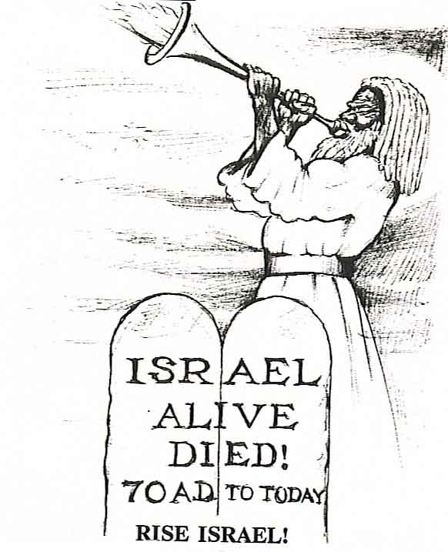

We Ended PART II (THE CONSPIRACY) finding the glorious Nation of Yisrael pictured in prophecy in the last days reduced to DRY BONES (a DEAD NATION), not even a skeleton of their ancient selves, buried in the OPEN VALLEY (Graveyard of America) as a living witness for the whole world to see just how low YAH’s chosen people can fall after rejecting His BLESSED WORD!
Let’s continue Ezekiel 37 and see what is the answer YAH gives to proverbial million dollar question, “Can these BONES (DEAD NATION) LIVE?”
THE RESURRECTION
Ezekiel 37:4-6,10-12: again, He said unto me PROPHESY (reveal the TRUTH!) upon these BONES (...DEAD NATION), and say unto them, O ye DRY BONES (LOST SHEEP Of the House of Yisrael), HEAR...THE WORD of YAH(YOUR SAVIOR).
Thus saith YAH YAHWEH unto these BONES (DEAD NATION); Behold, I will cause BREATH (LIFE) to enter into you, and ye shall LIVE:
And I will lay SINEWS upon you, and will bring up FLESH upon you, and cover you with SKIN in you, and ye shall LIVE (HEBREW YISRAELITE NATION); and ye shall know that I AM YAH (that RAISES THE DEAD).
So I PROPHESIED (REVEALED THE WORD) as He commanded me, and the BREATH (Understanding!) came into them, and they LIVED, and STOOD UP upon their feet, an exceeding GREAT ARMY!
Then He said unto me, son of Man, these BONES are the WHOLE HOUSE OF YISRAEL: behold, they (Gentile Nations) say, Our BONES (Nation) are DRIED (Dead!), and our HOPE (for REDEMPTION) is LOST: we are CUT/OFF (from Yisrael) for our PARTS (scattered).
Therefore PROPHESY and say unto them, Thus sayeth YAH YAHWEH; Behold, O MY PEOPLE (The so-called Negro), I will OPEN YOUR GRAVES, and cause you to come up out of your GRAVES (in America), and bring you into the LAND OF YISRAEL (your ancestral HOMELAND).
There is no other people on the face the earth who can be described as DRY BONES (a DEAD NATION) totally stripped of the KNOWLEDGE OF SELF, their NATIONAL IDENTITY, but the so-called Coloreds, the so called Negroes, the so-called Blacks, the African-American, Hebrew Yisraelite NATION!
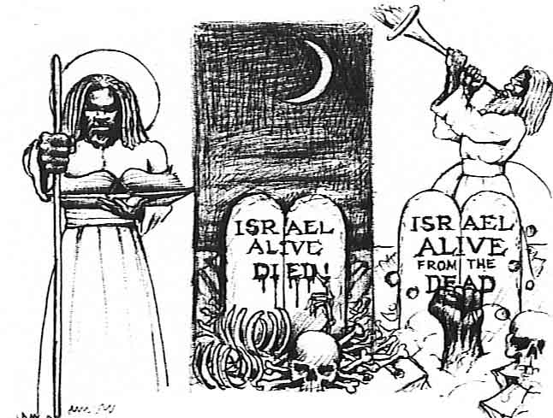
THE ETERNAL SIGN
(ALIVE, DIED, ALIVE FROM THE DEAD)
For this DEAD NATION there remains but one final slipper (SIGN), that is so powerful it can virtually RAISE THE DEAD (minded) NEGRO back to LIFE! This SIGN is YAH’s ETERNAL SIGN which is...ALIVE, DIED, ALIVE From the DEAD! It is the sign based on the fact that though there are many that are called gods (I Corinthians 8:5, 6), only YAH (the only TRUE EL) has the power to RAISE THE DEAD!
Deuteronomy 32:39 See now that I, even I, am HE, and there is NO GOD with ME: I KILL, and I MAKE ALIVE; I WOUND, and I HEAL: neither is there any that can deliver out of My hand.
Few people realize, not even so-called Bible scholars that such a SIGN even exists. But as you will soon see, no only does it exist, but it is the eternal Father’s GREAT SIGN pictured over and over again throughout the entire Bible.

MOSES’ SIGN
For example, if you notice very carefully you will see it was the ETERNAL SIGN (ALIVE, DIED, ALIVE from the DEAD) that was given to Moses when he was sent to deliver the ancient Nation of Yisrael (our forefathers) out of the old Egyptian bondage. Notice carefully the following SIGN!
EXODUS 4:1-4,6-8 AND Moses answered and said, But, behold, they (hard headed BLACK YISRAEL) will not believe me, nor hearken unto my voice: for they will say, YAH has not appeared unto thee.
And YAH said unto him, what is that in thine hand? And he said, a ROD.
And he said, Cast it on the ground. And he cast it on the ground, and it became a SERPENT: and Moses fled from before it.
And YAH said unto Moses. Put forth thine hand and take it by the TAIL. And he put forth his hand, and caught it, and it became a ROD in his hand:
And YAH said furthermore unto him, put now thine HAND into thy bosom. And he put his HAND into his bosom; and when he took it out, behold, HIS HAND was LEPROUS (WHITE!) AS SNOW.
And he said, put thine HAND into boson again. And he put his HAND into his bosom again: and plucked it out of his bosom, and behold, it was turned again as his OTHER FLESH(BLACK).
And it come to pass, if they (hard headed BLACK YISRAEL) will not believe thee, neither hearken to the VOICE of the FIRST SIGN, that they will believe the VOICE of the LATTER SIGN.
INTERPRETATION OF THE SIGN
The TWO SIGNS of Moses’ ROD turning into a serpent, and his HAND turning LEPROUS (WHITE) AS SNOW, are actually ONE SIGN (Genesis 41:25). Put them together and they SPEAK!
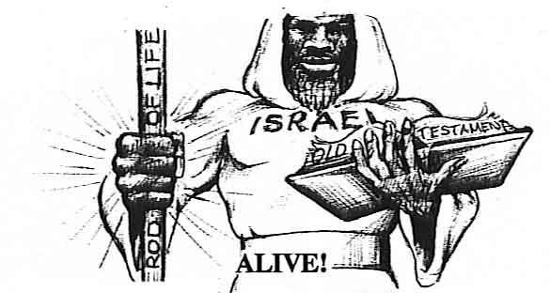
ALIVE
The ROD symbolizes LIFE (THE WORD of YAH). Moses symbolizes his people, TRUE BLACK YISRAEL. When we put the TWO SIGNS together, we see it reveals YAH’S WORD was the ROD of LIFE in ancient Yisrael.
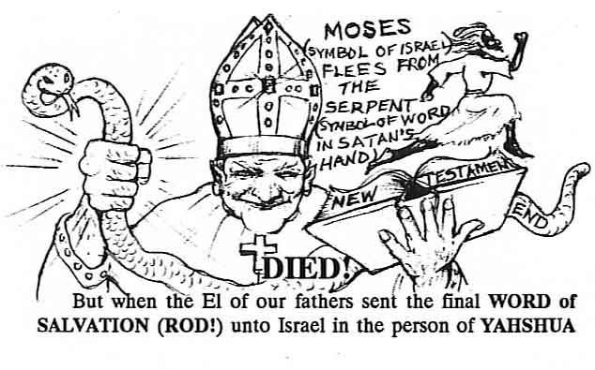

The MESSIAH (YAH’S WORD...MADE FLESH), as He explained in (John 1:14), Yisrael NOT UNDERSTANDING cast away their SAVIOR (THE WORD...ROD OF LIFE). This is symbolized in Moses’ throwing down the rod (Exodus 4:3)
After casting away their MESSIAH (ROD, WORD OF LIFE), true Black Yisrael soon DIED (70 A.D.) as a NATION and the conquerors, the Euro-gentile Nations (ROMAN EMPIRE) now took possession of THE WORD (ROD). But what was LIFE (ROD) for us, now became in the Euro-gentile’s LEPROUS (WHITE) HAND, a SERPENT (false Christianity = Satanic SUN WORSHIP) symbolic of DEATH “and Moses fled from before it.”
Today the manhood of our people has all but fled form WHITE CHRISTIANITY, because they can see it is SATANIC! But in casting away FALSE CHRISTIANITY, we have also inadvertently cast away OUR SAVIOUR (YAH’S SAVING WORD...the ROD OF LIFE). So we remain to this day the only Nation on Earth described as DRY BONES (a DEAD NATION), ignorant of the KNOWLEDGE OF SELF our true great and glorious ancient NATIONAL IDENTITY!
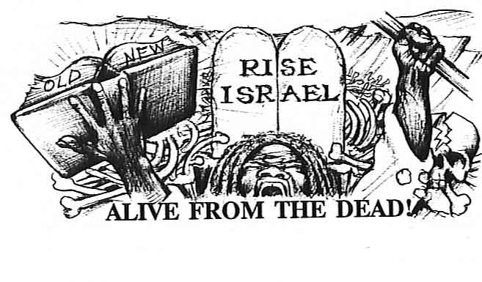
Notice carefully what happens next, for this is the SIGN for us today in the Graveyard of America. Moses, symbolic of the now DEAD NATION of Yisrael, was commanded to take the SERPENT (THE WORD that had been misinterpreted by the white Euro-gentile Nations) by the TAIL, meaning at the END or in the LAST DAYS of the Euro-gentiles’ time to rule on earth...or TODAY!
So Moses did as YAH commanded and took the SERPENT (symbol of false Bible teaching) by the TAIL (symbolic of THESE LAST DAYS) and what was a SERPENT (DEATH) in their WHITE HAND now became a ROD (WORD OF LIFE) again in Moses’ (true Yisrael’s) BLACK HAND and shows the miracle of LIFE FROM THE DEAD! HalleluYAH!
Hear, O my people, the ETERNAL SIGN (ALIVE, DIED, ALIVE from the DEAD) as it is for you (DEAD NATION) to take hold of this WORD OF LIFE (ROD!) and LIVE!
This same ETERNAL SIGN (ALIVE, DIED, ALIVE from the DEAD) was not only revealed to Moses, but if we notice carefully is the same SIGN revealed in the life of all the prophets. For example, we see the ETERNAL SIGN in the life of Noah saved from the waters of the FLOOD (symbol of DEATH), to Job redeemed from poverty and disease in ASHES (symbol of DEATH), to Joseph redeemed from the PIT and PRISON (symbol of DEATH), to Daniel redeemed from the LION’S DEN (symbol of DEATH), to the three Hebrew children redeemed from the FIERY FURNACE (symbol of DEATH), to Jonah redeemed form the BELLY of the FISH (symbol of DEATH), to ancient Yisrael redeemed from OLD EGYPT (symbol of DEATH), to YAHshua redeemed from the LITERAL GRAVE (DEATH), to US (the so-called NEGRO! The DRY BONES) brought in the BELLY of the SLAVESHIP to be buried in the GRAVEYARD OF AMERICA (all symbols of DEATH) awaiting our REDEMPTION.
Who else fits the ETERNAL SIGN (“slipper”) of ALIVE, DIED... and for those of us who would take hold of YAH’S SAVING WORD (the ROD OF LIFE) at the close (END) of this age can finally proclaim ...ALIVE FORM THE DEAD?
SUMMARY
Let us review the amazing prophecies (“SLIPPERS”) that have been uncovered in YAH’S WORD concerning who of all Nations can rightfully claim descent from the ancient HEBREW YISRAELITE NATION.
BIBILE PROPHECY concludes that if you find a NATIONALLY DEAD (Ezekiel 34:1-9) DARK SKINNED (Genesis 2:7, Amos 9:7, etc.) WOOLY HAIRED (Daniel 7:9, Revelation 1:14 etc.) people, who were SCATTERED (Deuteronomy 32:23) from their LAND (Yisrael, Northeast AFRICA), and SLAVESHIPPED into a land of BONDAGE (Deuteronomy 28:68) for 400 YEARS.(Genesis 15:13), where they would be BLINDED (Romans 11:7, 8), and as a result of a WORLD WIDE CONSPIRACY (Psalm 83:1-6) to keep them from their TRUE NATIONAL IDENTITY (land, language, and culture) and SAVIOR (YAH Elohim, Isaiah 45:15, 17, Isaiah 43:11), reduced to a PIG EATER (Luke 15:16), and finally CURSED (Deuteronomy 28:15, 68) to be the only Nation on earth to be identified by PROVERBS and BYWORDS (Negro, Nigga, Black, etc., etc., etc., Deuteronomy 28:37), and you have just found the HID TREASURE (Matthew 13:44), the PRODICAL SON (Luke 15:11-32) the LOST SHEEP (Matthew 10:6) of the HOUSE OF YISRAEL, who of all Nations is the only one to perfectly fit all these PROPHECIES (“GLASS SLIPPER”) like a glove.
After all this some might say “O well, what difference does it make?” for many of our DEAD MINDED brothers and sisters, this liberating truth has come too late. It was of them the Messiah spoke when He said: “Follow ME (THE WORD of YAH...into LIFE); and let the (SPIRITUAL) DEAD bury the (MENTALLY) DEAD (Negroes).” Matthew 8:22
Our fore parents were slaves. They were forbidden to read or write and were forced to work from can’t see in the morning to can’t see at night (Deuteronomy 28:65, 67). If they were caught trying to read or teach THE TRUTH (scripture), it meant certain death if caught. They transmitted the TRUTH the only way they could, through the SLAVE SONGS called ‘Old Negro Spirituals,” they cried to their Elohim for DELIVERANCE! Such songs as “Go down Moses,” “Cross over Jordan,” “Sweet Chariot,” etc., point out a people’s yearning for their HOME LAND. This yearning for home is summed up in a verse from the 137th Psalm.

Psalm 137:5, 6 If I FORGET thee, O JERUSALEM (YAH’s Holy City, Northeast AFRICA,...OUR HOME LAND!), Let my right hand forget her cunning.
If I DO NOT REMEMBER THEE, let my tongue cleave to the roof of my mouth; if I prefer not JERUSALEM above my chief joy.
Ever see a person afflicted, who has lost control of his limbs (“right hand forgot his cunning”), or who has been afflicted with a speech impediment (“tongue cleave to the roof of my mouth”)? That’s the pitiful condition of these Negroes today, who have lost ALL KNOWLEDGE of SELF (their TRUE IDENTITY). They can’t help themselves because Satan has hold of them. Yahshua was not exaggerating when he said, ”Howbeit THIS KIND (Demon possessed, Matthew 17:14-20) goeth not out but by PRAYER and FASTING. (Matthew 17:21) How true are the WORDS of YAH in the close of this age.
Hosea 4:6 MY PEOPLE (Yisrael) are DESTROYED for LACK of (Biblical) KNOWLEDGE.
II Timothy 2:15 STUDY to show thyself approved unto YAH, a WORKMAN that need not be ashamed, RIGHTLY DIVIDING the WORD of TRUTH (the Holy Bible).
Our fathers could not read or write, but were in a better condition than us today in MENTAL SLAVERY, who can read THE WORD, but don’t, choosing rather to sit up in CHURCH (the TOMB) or in front of the TELEVISION (the IDOL), and be bombarded by LIES day and night, until it is all but impossible for them to hear the TRUTH!
It is sad to report that most of YAH’s people have been in a “State of Death” for so long, they are now unable to live. For example, if a man has been buried in a cave for his whole life, when he “sees the light (WORD),” he is at first temporarily BLINDED. Or take an animal for example, who has been caged for his whole life. He will bark, tear and jump at you as long as he is in the safe secure surroundings of the cage. Open the door and he will just sit there. This is Yisrael under the CURSE today. We sing, “We Shall Overcome,” shout, “Black power,” and jump up and down about “being Free,” but as soon as the liberating TRUTH (THE WORD of YAH) comes to set us free, we just sit there in the dark prison of LIES Satan has put us in. And if we do hear the WORD and manage to escape, by and by, we go right back to the cage (prison of Lies) he has made for us, for it is all we know.

PART IV

THE SOLUTION

SOLUTION
(CLAIM YOUR ROYAL BIRTHRIGHT)
NO MORE BYWORDS: COLORED, NEGRO, BLACK, AFRICAN AMERICAN
NO MORE CURSES!
Deuteronomy 28:37
WE ARE...HEBREWS! YISRAELITES! A NATION!
We opened this chapter posing the question to what NATION (Nationality) does the SO-CALLED NEGRO belong?
(WHO AM I?)
By the undisputable FACTS revealed in YAH’s HOLY WORD (glass slipper)...OUR SAVIOR which no other people on earth can fit, we can now claim our GREAT and GLORIOUS, ROYAL BIRTHRIGHT as YAH’s ancient HOLY PEOPLE, the CHILDREN OF YISRAEL.
The FACT that we can prove to be the rightful descendants (SEEDS) of the lost tribes of Yisrael is not enough if we only continue to identify ourselves by the slave NAMES which keep us chained to the CURSE!
Deuteronomy 28:16 CURSED shalt thou be in the city (NEGRO). CURSED Shalt thou be in the field (NIGGA).
Deuteronomy 28:37 And thou (TRUE YISRAEL) shalt become an astonishment (NIGGER), a proverb (NEGRO), and a byword (BLACK), among ALL NATIONS (English, French, Ethiopians, etc,) wither YAH shall lead thee.
We are the only people on the face of the earth that is CURSED To identify ourselves and the organizations that represent us after BYWORDS: (Black Student Union, United Negro College Fund, National Association for the Advancement of Colored People, etc.). All other Nations as we have seen earlier in this chapter are IDENTIFIED by LAND, LANGUAGE, and CULTURE. Where is COLORED land, NEGRO land, or BLACK land?
No other Nation on the face of the earth identifies themselves, or the organizations that represent them after their SKIN COLOR. For example, our African Ethiopian brothers do not call their church the BLACK Church of Ethiopia, but simply the ETHIOPIAN Coptic Church. Likewise ALL other NATIONS name themselves and the institutions that represent them after their NATIONAL NAME. Even in America (BABYLON, “out of Many Nations one”) all other peoples retain their NATIONAL IDENTITY (Italian American, Japanese American, Mexican American). Where are the institutions and organizations that represent us HEBREWS?
Hosea 3:4 For the children of Yisrael shall abide MANY DAYS (over 2000 years and still counting) without a KING, and without a Prince, and without an image, and without an ephod, and without teraphim (without a government). We must reclaim our rightful IDENTITY as HEBREW YISRAELITES, the truth that will finally FREE us as a people.
HEBREW comes from the name of our forefather, EBER (Genesis 11:16, 17), meaning “one who has crossed over.” He was the descendant of SHEM (Genesis 11:10). This means we are an African Semitic people. Thusly, the “anti-Semitic” label couldn’t apply to us, lest we be accused of being “anti-SELF” SHEM in turn was the forefather of ABRAHAM (Genesis 11:26), who begot ISHMAEL (Genesis 25:12), and his brother, by promise ISAAC (Genesis 25:19), who begot Jacob (Genesis 25:26) whose name was changed to YISRAEL (Genesis 32:28) who is the father of the twelve SONS (tribes) of YISRAEL (Genesis 46:8-26) our ancient forefathers. The HISTORY BOOK the world knows as the Holy Bible is only revealing and fulfilling the PROMISES and PROPHESIES made with that ancient African, Semitic, Hebrew Yisraelite NATION, which as we have seen only fits us, the (ACCURSED) SO-CALLED Negroes or Blacks, to the LETTER.
We must replace all these ACCURSED NAMES used by our enemies an invisible chain to keep us down, and replace them by our TRUE NATIONAL NAME. For example, if you happen to be a Muslim, no problem, you are a HEBREW Muslim, not a Black Muslim. If you are a Rastafarian, no problem,; you are an YISRAELITE Rasta. If you are a Christian, no problem, you are YISRAELITE Christian. If you are an American, no problem; you are HEBREW YISRAELITE American. Not a BLACK American.
The truth that can finally UNITE YAH’s people is so very simple, yet Satan has managed for four hundred years to brand us with the ACCURSED NAMES (Colored, Negro, Black, etc.). By allowing other Nations to disrespect us by these CURSED BYWORDS; Colored, Negro, Black, African-American, etc. to name us, we allow them to in effect keep us a NON-PERSON!

...UNDERSTAND!
The single purpose of this writing is simply to make the SO-CALLED NEGRO aware of what every other people inherit at birth...their NATIONAL IDENTITY!, regardless of religious, philosophical, and doctrinal differences, which would come under RELIGION...NOT NATIONALITY! And tends to DIVIDE and NOT UNITE!
UNDERSTAND! Whether a so-called Negro is atheist or thinks he is god, is religious or heathenistic, educated or ignorant, Christian or Muslim, white minded or black minded, it doesn’t matter. The fact is BIBLE PHROPHECY (the ‘glass slipper” which CAN’T LIE) proves by NATION(...NOT RELIGION!) only the SO-CALLED NEGRO can claim to be the SEED of the ancient Black HEBREW YISRAELITE NATION.
This means that such notables in our past as Nat Turner, Fredrick Douglass, Harriet Tubman, Sojourner Truth, Booker T. Washington, Marcus Garvey, Martin Luther King, Jr., Louis Farrakhan, Coretta Scott King, Maya Angelou, Michael Jordan, Mike Tyson, Michael Jackson, etc., etc., etc., are ALL HEBREW YISRAELITES by NATION (...NOT RELIGION), but NATION! NATION! NATION! NATION!
I am sure if these persons were asked they wouldn’t deny their great royal NATIONAL HERITAGE, being descended from the ancient Black Kings and Queens of Yisrael, especially after examining the evidence presented in this book. But if they should deny their ROYAL BIRTH RIGHT, politely ask them to what NATIONALITY do they belong?
The fact is the Bible proves the so-called Negroes are HEBREW...no matter what we ‘WANNA BE. “

NOTE: The book Hebrewisms of West Africa states that the Yoruba, Hausa, Fulani, and many West African tribes have Hebraic rites and customs that prove many of them are the direct descendants of the ancient tribes of Yisrael.

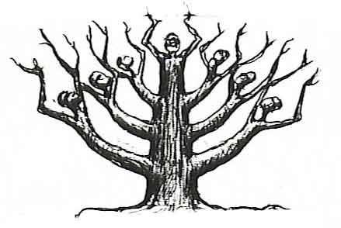
SAVIOR WORD OF YAH MINISTRIES
For this cause SAVIOR WORD OF YAH MINISTRIES is establishing Hebrew Yisraelite Survival to specifically promote and enhance NATIONAL IDENTITY among the over eighty million peoples of African Hebrew ancestry, supplying our communities with HEBREW CULTRURAL CENTERS dedicated to the Education, UNITY, and Preservation of YAH’s Holy People, against those racist and genocidal element whose aim for four hundred years has been to keep Hebrews under the CURSE, ignorant, divided, and destroyed!...in that order.
SAVIOR WORD OF YAH’S first order of business will be to launch an all out campaign to erase the accursed BYWORDS and PROVERBS used to identify us as a people.
Hebrew Yisraelite Survival
NO MORE BYWORD!
COLORED, COON, NIGGER, NEGRO, BLACK, AFRICAN AMERICAN NO MORE CURSE!
Deuteronomy 28:37
I AM HEBREW! YISRAELITE! AFRICAN!
Please understand that we aren’t saying to be of the so called BLACK (race) is a CURSE. We must love our BLACKNESS, and be proud that we are the original man. But to be identified solely by COLOR while all other NATIONS identify themselves by ancestry, land, language, and culture, is a CURSE! Every time a person of another Nationality calls you BLACK in reference to your Nationality, he is cursing you.
Names carry a spirit. There is strength in a name. Those of us who fulfill the prophecies (Genesis 15;13, 14) of being Hebrews, no matter what our religious, political, and philosophical differences might be, must ban together and cast off the BYWORDS used to identify us and the organizations that represent us, demanding to be called what we are...HEBREW YISRAELITES! And though we are Nationally Hebrew Yisraelites, because Yisrael is located in northeast Africa, we are also AFRICANS!
We must demand our rightful birthright before we can expect to be respected by other Nations. You can have all the religion, education, money, and power in the world, to the other Nation of the world you are just a religious, educated, rich, influential, CURSE (Nigga, Colored, Negro, and Black). Do you honestly want your children to continue to grow up ignorant among all the many other Nationalities, having to continue to identify themselves by a COLOR?

CALL TO NATION (UNITY!)
Before we as a people in this country knew anything about Islam, Rastafarian, Egyptology, Pan-africanism, etc., there existed the so-called black (HEBREW) church, which served as our Nation’s spiritual, political, economic government in exile. At that time the church was alive, functioning as the center, life blood of the community. Those were the days Black (Hebrew) men were strong, and didn’t play when it came to their commitment to Creator and family. The purpose of the church at that time was clear, help the BLACK MAN (FAMILY) to SURVIVE.
As we had no ballot or rights being slaves, the church functioned as a kind of underground government for the Nation, providing for the whole community. There weren’t any welfare or government agencies to assist us in those days. It was the church that provided shelter or the homeless, food and clothing for the widow. It was the church who hid runaway slaves, and was on the cutting edge of the controversial issues of the day, supplied direction and inspiration drawn from the exploits of the Biblical patriarchs and matriarchs like Moses, Joshua, Abraham, David, Deborah, Judith, and Yahshua (whom they knew as Je Zeus), etc.
The more militant element (field hands) identified with Moses, correctly likening their situation to that of the oppressed Hebrew slaves down in old Egypt, who yearned for a Savior to come and deliver them form the cruel injustices of slavery, to the light of a FREE NATION! It is this more militant element (MANHOOD) of our Nation, which has long ago left the church, and today can be found among the so called Black (HEBREW), Muslims, Rastafarians, Pan-Afranists, etc., or the ever increasing militant gang presence in our city streets.
It was primarily women and establishment type Blacks (house Negroes) who identified with Je Zeus resolving to Trust in gods, and the master’s benevolence to, “in the sweet by and by”, set them free.
Today the Black (HEBREW) church is still by far the most powerful force in the Hebrew community, but has been greatly weakened as a result of its ineffectiveness to attract its MANHOOD! (The strength of any Nation). Today it has become no more than a business...BIG BUSINESS! And like many of our businesses controlled by White America, its primary business is to keep the natives ignorant, happy, grinning, singing, looking up to their White masters to fulfill THE DREAM of a just America (Heaven), when the stark reality down here on earth being a hellish NIGHTMARE. Our communities have been reduce to literal jungles of immoral cesspools of violence, where one has to learn to wade through the quagmire of drugs, gangs, homosexuality, AIDS, single parent families, welfare, birth control, abortions, etc., to keep from drowning.
We call on the leaders of this great people to STAND UP! Be armed with the WORD OF TRUTH, and boldly claim our NATIONAL IDENTITY! Only under the power of the WORD armed with the knowledge of our NATION, will we be able to come together to overturn the genocidal effects of this racist system which threatens to make us the endangered species.
Remember we ALL (MEN, WOMEN, Christian, Muslim, Rasta, Pan- Africans, etc.) came here as ONE PEOPLE in the stinking belly of the SLAVE SHIP to fulfill YAH’s WORD. And whether man, woman, rich, poor, light dark, Christian, Muslim, Democrat, Republican, and any other thing that divides us, we are ALL as a people in the same boat (at the bottom) today. “United (as a NATION) We STAND, divided (by RELIGIONS) we FALL.” RISE YOU MIGHTY NATION!
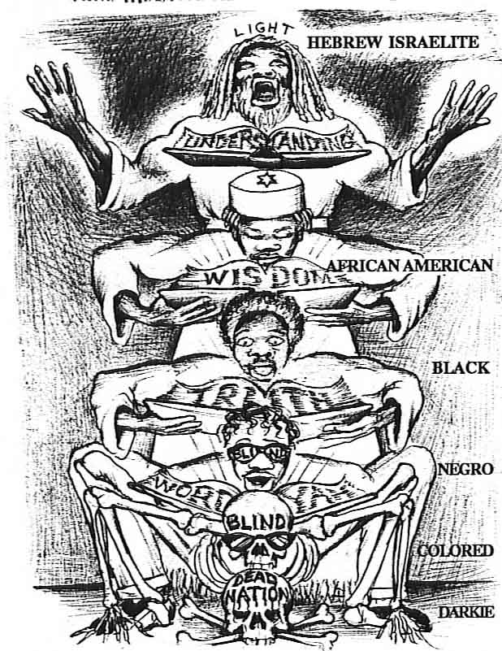

RISE YOU MIGHTY NATION!
There remains but on last step which, when we as a people shall take, will empower us like magic to step out of the CURSE which has bound us for so long. That final great step is NATIONAL IDENTITY. We must begin to understand, identify, and function as the great HEBREW YISRAELITE NATION we are.
In Ezekiel 37, the scripture YAH described us as DRY BONES(...a DEAD NATION) buried in the OPEN VALLEY (Graveyard of America), notice carefully the scripture specifically reveals that our resurrection from this wretched condition would be in STAGE...or STEPS.

Ezekiel 37:7, 8 So I prophesied (revealed the WORD) as I was commanded: and as I prophesied, there was a noise, and behold a shaking and the bones came together, bone to his bone.
And when I beheld, lo, the sinews and the flesh came up upon them, and the skin covered them above; but there was NO BREATH(...NO UNDERSTANDING...NO LIFE) in them.
This scripture dramatically corresponds to the slow but steady advance we as a people have made from being a DEAD NAITON, having been stripped of everything (identity, land, language, culture, etc.), to one today looking back to Africa on the brink of discovering our true great ROYAL BIRTHRIGHT (...BREATH...LIFE).
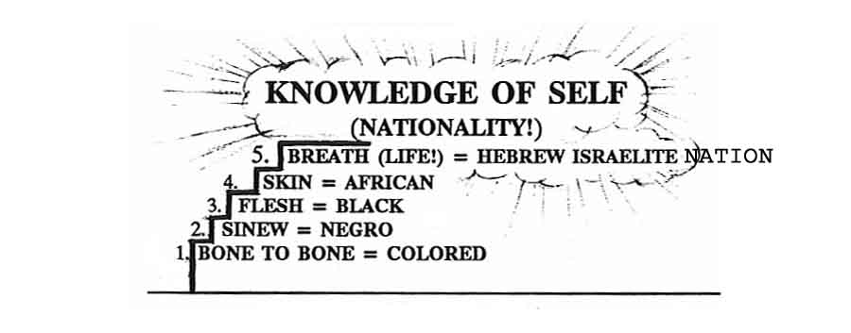DEAD LEVEL DRY BONES = NIGGA, DOG

THE FINALSTEP
We used to be totally DEAD (DRY BONES), called DARKIES, NIGGERS, (based on our skin color) in slavery days. Then came physical (not mental) freedom and the demand to be called COLORED (based on skin color). Next was the demand to be called NEGRO (Spanish word for black), still color. And the next step was the Black movement of the late sixties, which demanded that the Spanish name NEGRO be changed to the English word BLACK (yes, still based on color).
Now there is an effort under way to address us as African American. HalleluYAH, Praise YAH we are getting closer, we are at least now on the continent.
DON’T STOP NOW! There is just one final step to take for the people of YAH to step out of the CURSE that has bond us for four hundred years from FREEDOM! That final step is to DEMAND to be called by our rightful NAME...HEBREW, YISRAELITE, AFRICAN!
This chapter opened with Hosea 4:6, “ My people are DESTROYED for a LACK OF KNOWLEDGE.” But HalleluYAH! We can end it with John 8:32, “And ye shall KNOW the TRUTH”(THE WORD of YAH!), and the TRUTH (THE WORD) Shall make you FREE!

THE BEGINNIG
NATION TIME

